Welcome to Multisensory Futures
  - A resource hub for the creative industries
Imagine a future in which you can feel your favourite stories – sensing the heat and vibration of a high-speed car chase or crunching leaves under your feet as you walk towards a deserted house in the woods. In real life, we experience the world in multiple ways at once: seeing, hearing, touching, smelling, even sensing our own heartbeats. If the technologies of the future can simulate multisensory experience more fully, this will bring our imagined worlds to life more vividly, delivering more meaningful engagement, intense emotions and longer-lasting memories for audiences.
This hub is designed to help make that future a reality, providing insights, tips and resources for working inclusively with the senses. Think of it less like a report you read and more like one you explore – a richly interactive map of multisensory ideas, references and design nudges which you can lift straight into production.

Why multisensory now?
Multisensory work matters: it can deepen presence and emotion as well as create longer-lasting memories. [Multisensory Value] There is also a growing appetite for immersive, interactive and multisensory events, particularly where they support meaningful emotional engagement. [Audience trends towards multisensory]
But more sensation isn’t the point. The point is the right sensation, at the right time, grounded in purpose. Indeed, less sensation can often be more! [Multisensory experience]

Inclusion isn’t a bolt-on and multisensory isn’t automatically inclusive
Openness is required when creating inclusive multisensory experiences, as we cannot presume to know what all users need. For instance, while the introduction of haptics is often considered helpful for all blind individuals, preferences, abilities and situations vary significantly. Treating haptics as a tick-box inclusion measure risks overlooking this diversity and may act to limit creative exploration for inclusion. [Multisensory experience]
The temptation to add new and exciting sensations also brings with it a risk of overload. When sensory input becomes too overwhelming for someone, tools like sensory guides and refuge spaces can matter just as much as the effects themselves. [Multisensory Value]

Design lessons you can use immediately
1) Lo–fi can do serious heavy lifting... if it’s motivated
In Current, Rising – a location–based hyper-reality opera combining Virtual Reality (VR) with free-roam movement, wind, floor vibrations and more – audiences reported that blowing wind and free movement had the greatest impact on their sense of presence. However, Figment Productions – the company that created Current, Rising – reported that one of the best sensory effects they ever delivered was created far more simply, via gravel glued onto hardboard that people walked on. It cost only a few pounds, yet it made a huge boost to immersion. [Case study: Current, Rising]
Tip: Even very simple sensory effects can have significant impact if they are clearly connected to the audience’s expectations. Context and motivation matter.
2) Chase quality of experience, not just quality of service
There is a clear and highly practical distinction between what technical teams measure – quality of service, such as bandwidth, jitter, latency – and what audiences perceive – quality of experience, including smoothness, responsiveness, comfort and immersion. These two aspects don’t always align. For example, our brain can tolerate small timing mismatches, so absolute zero latency isn’t always necessary. [Latency tolerances]
Tip: Decide what must be tight, typically: action → visual response, and where you can spend a little slack, usually in secondary cues. Then test early with diverse user groups. [Latency tolerances]
3) The smallest effect often gets remembered
DARKFIELD’s Arcade is a strong example of story-first sensory approach: binaural sound in pitch blackness, a branching narrative and the principle that often the smallest effect can have the biggest impact. The water spray, sensed as the splashing of blood in the experience, is the one most people remember, because it’s integral to augmenting the audio aspect it accompanies. [Case study: Arcade]
Tip: Ask direct questions during reviews. For example: “If we removed this effect, would the meaning of the moment change?” If not, it’s likely decoration, rather than storytelling.

What next?
This Hub will evolve and grow, expanding through industry engagement and original new research, and eventually also incorporating shareable multisensory tools.
We feel that this reflects the true spirit of multisensory design – that it is not a fixed set of rules, but rather a shared, living set of ever-improving patterns. These are tested in real rooms, with real people, through open discussion. And sometimes it’s still about gravel glued to hardboard.

  - What are you looking for?
[top-level headings]

ABOUT page

This site is created and run by the CoSTAR National Lab Inclusive Users team.
[Brief intro to CSNL with links]
[Team pics and short bios]

Audience trends towards multisensory
Immersive, interactive and multisensory events are growing in popularity, particularly where they support meaningful emotional engagement. These are linked to a range of audience drivers and it is increasingly recognised that the senses play a key role. Here are some trends that we have been observing.

Trends by age
- Gen Z want goosebumps: When compared to other generations, Gen Z indicated the strongest need for engaging brands (65% Gen Z agreed to “I want to live in a world where brands think giving customers goosebumps is important.”), followed by the Millennials (64%) and Gen X (53%).¹
- Younger generations are used to interactive media: Engagement with video games is increasing by generation. For example, Gen Alpha spend 22% of leisure time per week gaming, followed by Gen Z with 19% and Millennials with 18%.¹ The most recent Ofcom report highlights that 61% (3.5m) UK 8 to 14-year-olds play Roblox.²
- Gen Z are also concerned about technology: There also appears to be a raising concern about the impact of technology, recognised by younger generations. For example, 59% Gen Z were concerned about echo chambers created by algorithms.¹
- Young adults as the main audience for immersive experiences: In the Immersive Experience Network’s 2024 audience report, young adults (aged 16 to 34) accounted for 50% immersive audiences, while those aged 45 and overrepresented only 25%.³ (NB we consider the umbrella term immersive to include multisensory experiences).
- Immersive audiences are much younger than traditional theatre audiences: The majority of recent West End attendees were 45 years and over, according to a Society of London Theatre & UK Theatre survey conducted in 2024 and 2025.⁴
- Immersive audiences are similar to cinema-going audiences: For example, young adults (aged 16 to 34) accounted for 37% cinemagoers in 2020, rising to 42% in 2022.⁵
- Gen Alpha crave unique sensory-enhanced live experiences: A recent US-based report (2025) on the youngest generation of movie theatre-goers, Gen Alpha (aged 12 and under in 2025), suggests a preference for live, distinctive entertainment experiences, making them more inclined to in-person viewing than streaming, even when compared with Millennials. Note that they want experiences not easily replicated at home, including large-format screenings, 3D, Virtual Reality (VR) and multisensory formats. Examples highlighted include wind, lights and seat movement.⁶
- Younger generations are more likely to prioritise communal experiences than Millennials or Gen X: US-based data indicate that spending time with friends and family was the most commonly reported reason for cinema attendance among Gen Alpha and Gen Z, whereas this was not the leading factor for Millennials and Gen X.⁶

Trends by location
- London as a hotspot for immersive experiences: Londoners made up nearly a quarter of all UK-based immersive audiences (22%). They also appear to go marginally more regularly than those in other regions. Nonetheless, for many this is considered a special occasion.⁷
- This is different to geographic metrics for cinema, which seem more balanced across the UK: Most regions around the UK fluctuate between 36% and 43% people that watched a film in the cinema in 2021 and 2022.⁸

Trends by personality
- Not all audience members seek active interaction: Interactive experience designers often use audience personas that include paddlers (prefer to observe), waders (are happy to engage but slightly reserved) and swimmers (completely immersive themselves in stories).⁷
- Personality traits also influence engagement: Openness to experience has been identified as a key personality trait in people with an interest in diverse art forms, including modern and abstract art forms.⁹

Multisensory Value
Multisensory work is reshaping how we create, experience and value cultural, commercial and artistic experiences. Understanding its value can help us unlock new opportunities, which we expand on below.

Economic value
Multisensory experiences aren’t just novel, they’re profitable. The economic value examines how multisensory elements drive revenue, market growth and return on investment in the context of creative industries.
- The economic value of experiences engaging multiple senses has been recognised since the 1990s: Experience-economy theorists Joseph Pine and James Gilmore highlighted that engaging all five senses is a powerful way to design memorable experiences, an economic offering in its own right. They argue that:
Smart shoeshine operators augment the smell of polish with crisp snaps of the cloth, scents and sounds that don’t make the shoes any shinier but do make the experience more engaging. Savvy hairstylists shampoo and apply lotions not simply because the styling requires it but because they add more tactile sensations to the customer experience. Similarly, grocery stores pipe bakery smells into the aisles and some use light and sound to simulate thunderstorms when misting their produce.¹⁰
- Industries built on immersion are booming: For example, theme parks, which are inherently multisensory, are valued at $64.6B (global market; 2023), which is projected to nearly-double by 2032 (~$113B) due to growth at ~5–6% per year.¹¹
- Multisensory elements could represent competitive differentiation and attract new audiences: Offering something beyond standard audiovisual presentation can attract new audiences and encourage repeat visits.¹² This may open pathways for entirely new forms of entertainment, art, training and communication.
- Multisensory engagement was listed as one of the top 10 drivers of brand engagement in VML Intelligence 2023 report¹ (i.e. answers to question “I’d be more likely to purchase a brand if it...”), alongside factors such as inducing intense emotion, transporting people to another world and creating a sense of connection to something bigger, while bringing a sense of joy ranked highest overall. However, the importance of multisensory engagement varies by generation: Gen Z and Millennials rated multisensory brand engagement as less influential, whereas Gen X and Baby Boomers placed greater value on it.
- Return on sensory investment (ROSI) is poorly researched but the field of sensory marketing suggests it is promising: Some statistics suggest that sensory marketing increases sales by 10%.¹³ Academic research observes similar trends, such as research conducted by the University of the Arts Helsinki suggesting that playing nature sounds in a supermarket increased the sales.¹⁴
- However, multisensory can be cost-intensive: It often demands more computer power, equipment and additional operational support. Integrating multisensory elements may also require extra time and staff for setup and onboarding.

Social-emotional and cultural value
The social-emotional and cultural lens focuses on the impact of multisensory experiences on individuals, communities and culture. Evidence suggests that integrating multiple senses can increase emotional engagement, foster pro-social behaviour and social connection. Engaging multiple senses can also support more accessible experiences by offering alternative ways for people with diverse sensory needs to experience stories, particularly when traditional media has heavily relied on sight or sound.
- Multisensory integration amplifies aesthetic experiences: Recognition of the social-emotional impact of multisensory integration goes back to the 19th century, with the foundation of the field of experimental aesthetics and its founder, Gustav Theodor Fechner, emphasising the importance of multi-layered experiential perception, including engagement of multiple senses, for rich aesthetic experiences and full appreciation of beauty.¹⁵
- Multisensory can engage audiences in more meaningful ways: Experiences that stimulate multiple senses have the potential to engage their audiences in more active and meaningful ways. For example, in museums the field of sensory museology has emerged in response to traditionally hands-off, visually dominated approaches (single-sense epiphanies).¹⁶ Evidence now shows that novel and immersive approaches can create more engaging and memorable museum visits.^{12,17} Our senses are deeply tied to our emotions: music,⁸ colour,⁹ texture¹⁰ and even scent¹¹ can powerfully shape mood and audience response, creating more impactful narratives. Multisensory elements make experiences more compelling and immersive, leading audiences to feel more present and connected, boosting satisfaction.¹⁸
- Stimulating multiple senses can boost well-being in virtual environments: In one study exploring virtual urban green spaces, participants experienced different combinations of sensory stimulations, with eight possible combinations. Those exposed to four or five senses (visual, auditory, olfactory, tactile and taste) showed the most positive impact on blood pressure recovery and psychological recovery, compared with groups receiving fewer sensory inputs (such as audio + visual only). However, this is just one study in relation to a particular type of virtual environment (nature), and there is a big research gap in terms of understanding which senses and which combinations have the best impact on physiological and psychological well-being.¹¹
- Smell and memory are strongly intertwined: The connection between memory and smell is well-researched and evidenced, as the two brain centres are strongly linked – think of how a specific smell can instantly bring to mind a past moment.¹⁹ Therefore, it is unsurprising that multisensory learning is a well-supported research area.²⁰ Multisensory experiences are often more memorable long after they occur; when multiple senses reinforce the same idea, learning tends to become stronger and more memorable.^{21–23}
- Multisensory for place-making and preserving cultural heritage: It is increasingly recognised that engaging multiple senses could play a role in facilitating cultural understanding and connections. Such approaches are increasingly used in tourism to facilitate cross-cultural connections (e.g., food experiences)²⁴ and cultural heritage documentation (e.g., sensory heritage experiences). ²⁵
- Multisensory design can also enhance accessibility and inclusion: Multisensory design provides information through multiple sensory channels, offering alternative ways for people with diverse sensory needs to access and enjoy experiences.^{26,27} Many of these approaches, such as audiobooks and subtitles,²⁸ have become popular in their own right. For example, many museums are moving towards multisensory exhibits as a way of making their collections more accessible for those with visual impairments. Research conducted with scented guided tours in the Rijksmuseum, Amsterdam, reported that visitors who were blind or had low vision felt more engaged and understood the artistic objects better through olfactory stimulation.^{29,30} Inclusion considerations are elaborated on throughout.
- When sensory input becomes overwhelming, guides and refuge spaces are equally important: When discussing inclusion and sensory experiences, one must recognise that not everyone processes sensory information in the same way; some people are highly sensitive to stimuli while others may need stronger input to engage. Therefore, initiatives such as sensory guides and refuge spaces are also extremely important inclusion practices.³¹
- Newly developed experiences can also introduce unexpected barriers: By involving diverse audiences through the production process, from early ideation to final delivery, creatives can identify barriers and make the adaptations needed to ensure experiences are welcoming and accessible for everyone.

Multisensory experience
All experience is multisensory. Our senses are constantly combining and interacting to give us the best possible understanding of the world. This section could offer a range of creative provocations, both in finding novel techniques for simulating sensory experience and in combining the senses in new and interesting ways. What follows is not a comprehensive account of multisensory experience but an overview of some selected multisensory effects and interactions that might be particularly relevant for converged media production and experience.³²
A word of warning. From an inclusion perspective, considering experiences in terms of multisensory works best when guided by openness rather than fixed assumptions about what people need. Haptic sensory substitution, for example, is often assumed to benefit all blind people; yet people’s preferences, abilities and contexts differ greatly. Treating haptics as a tick-box inclusion measure risks overlooking this diversity and may even act to limit creative exploration for inclusion.

There are several ways in which multisensory experiences can be designed to promote inclusion:
- Adaptation enhances accessibility by tailoring the sensory experience for diverse audiences. In Punchdrunk’s Viola’s Room, participants explore an environment while listening to an audio experience through headphones. Demonstrating adaptation, individuals with hearing loss in one ear can opt for mono audio to improve their experience.
- Substitution allows for information that would be communicated in one sense to be communicated in another. If participants had a visual impairment, in addition to the audio narration, descriptions of the environment could be overlaid. In Punchdrunk’s Viola’s Room, multiple accessible listening options are available, including dialogue-enhanced and audio-described.
- Integration, on the other hand, involves including additional sensory elements. Someone with audio processing needs might find subtitles helpful. Conversely, it is also important to consider allowing for some sensory elements to be switched off, such as flashing lights.

Creative opportunities: Playing with expectation
As we build up multisensory experience throughout our lifetimes, we develop expectations about the types of sensory input that are likely to appear together. For example, if you see that you are approaching a rose bush, you may also start to expect the smell of roses. In the following sections, we consider some creative opportunities that these multisensory expectations might provide. Building on the example, if it turns out that the roses actually smell of peppermint then this is likely to surprise and perhaps delight an audience (whereas if the roses smell of something unpleasant then that could be shocking and unnerving).

Sensory substitution

Left Figure: 3D-printed tactile map generated with Touch Mapper, showing raised braille and surface features of Egham, UK. Right Figure: the corresponding OpenStreetMap base map of the approximate same area of Egham as shown in left. Map data © OpenStreetMap contributors, available under the Open Database License (ODbL).
It is increasingly possible to translate information from one sense into another, a process known as sensory substitution (e.g., sound to vibration via haptic vests; vision to audio sonification). This may happen in real-time (e.g., haptic navigation vests) or through pre-prepared representations such as tactile diagrams. In the figure above, a tactile map portrays visual information represented in tactile form; this can improve accessibility by providing alternative ways to represent information for people with diverse sensory needs (e.g., providing real-time subtitles for people with hearing loss). It also opens exciting creative opportunities, for example, through translating a performer’s body movements into sound and light, such as in Steady State.
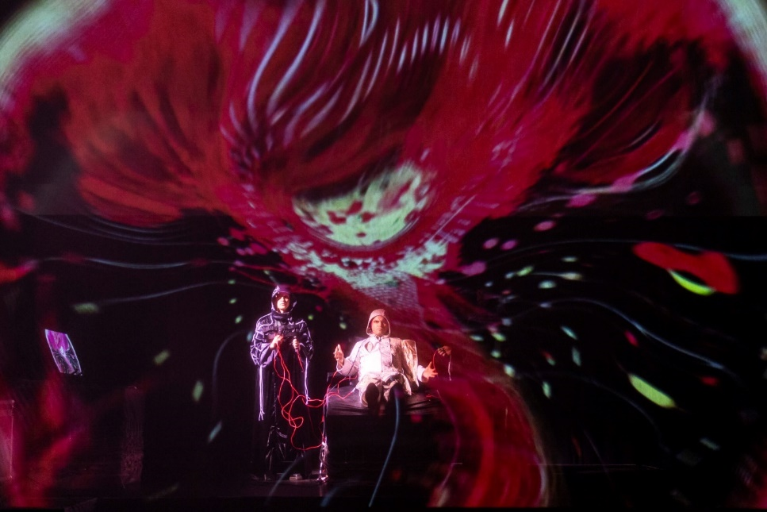
Mid-performance photograph of Steady State. © R. Murphy O’Sullivan, 2024.

Case Study: Steady State
Created by performer-technologist and research lead Zubin Kanga (Royal Holloway, University of London), composer Alexander Schubert (Musikhochschule Hamburg), brain sensor and neuro-diagnostics company ANT Neuro (Netherlands/UK/Germany), brain-computer interaction engineer Serafeim Perdikis (University of Essex) and a wider team of artists, Steady State (2024) recasts the recital format as a retro-sci-fi laboratory in which the performer is both subject and instrument. Steady State was created as part of Cyborg Soloists, Zubin Kanga’s UKRI Future Leaders Fellowship research project.
Wearing an ANT Neuro Electroencephalography (EEG) cap, hand-controlled motion sensors and multiple muscle sensors, the artist Zubin Kanga streams brainwave rhythms into a custom Max system, while finger movements and torso gestures are routed to TouchDesigner for real-time processing. This system simultaneously moulds and morphs the immersive electronics sounds and sculpts dreamlike holographic projections. Using Steady State Visually Evoked Potential signals (a standard brain–computer interface technique), Kanga controls audiovisual patterns by focusing on different strobing objects, facilitating the first ever use of brain sensors to consciously control sound and visuals on stage. Finger articulations trigger a virtual piano via motion sensors, while Electromyography (EMG) sensors modulate the bass electronics. In the work’s climax, the performer’s brain and the audiovisual system enter a feedback loop, accelerating to a hallucinatory and transcendental conclusion.
500 people have already attended the live performance, with a further 1400 viewing the work online. The research has extended the use of ANT Neuro's technologies, which are already used extensively in medical, therapeutic and psychological research contexts, into musical performance. Beyond artistic practice, these new tools hold potential for broader applications in music education and music therapy. The team is also developing open-source software and a new mobile app version, ensuring the widest possible access to these technologies for artists, educators and researchers alike.

Case Study: Watch-based haptic navigation
Apple Watch uses distinct haptic patterns paired with brief tones to signal left versus right, turns and arrival, letting people navigate without inspecting a map. This feature can now work when there is no internet connection. Similar navigation is available with Google Maps on mobile and Wear OS (see figure below).

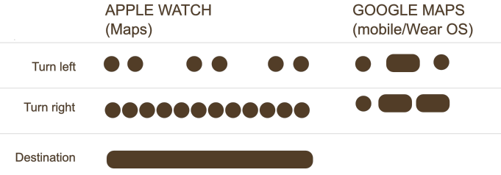
Illustrative haptic navigation patterns across smartwatch platforms. © A. Woods, 2026.

Crossmodal illusions
The senses can interact in ways that create a range of illusions, where information from one sense alters how we perceive another. Some of these could have interesting creative applications. For example:
- Anti-gravity illusion: By constructing an environment with a sloped floor but building the walls and props perpendicular to that slope, the visual cues convince people that they are standing upright even when they are actually standing at an angle. Other people in the room can then appear to lean at impossible angles, upside down, or pour liquids uphill.
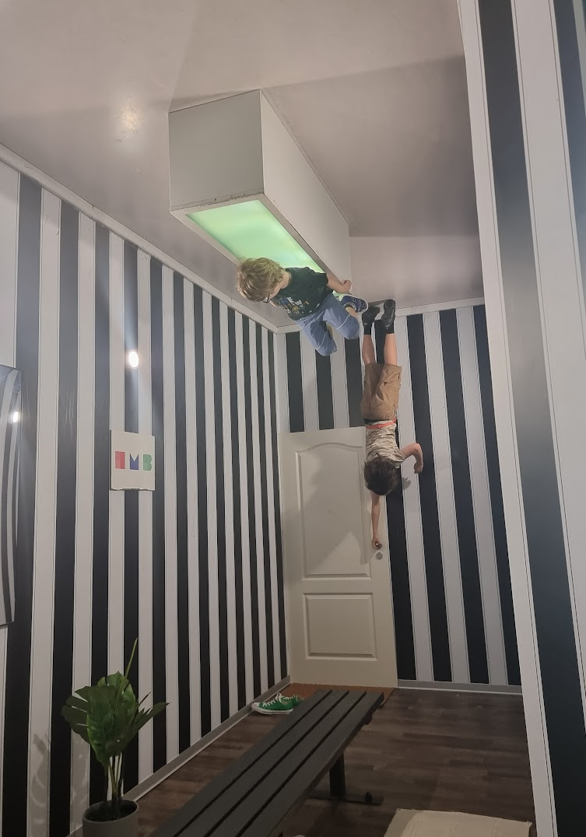
The Reversed Room at Illuseum Berlin. A rotated set makes visitors appear to stand on the ceiling, creating an upside-down gravity effect. Photo: © A. Woods, 2023.
- Rubber Hand illusion: Visual and tactile information can be integrated to alter a person’s sense of body ownership. In a typical setup, the person’s real hand is hidden from view, while a visible fake, or rubber hand is placed in front of them. When the (hidden) real hand and (visible) fake hand are stroked in the same way at the same time, 80% of people report feeling that the rubber hand is becoming part of their own body³³. Similar principles extend to whole-body illusions in VR, where synchronous visual and tactile stimulation can induce the compelling experience of inhabiting a virtual avatar³⁴.

- Parchment-skin illusion: This illustrates how auditory information can influence tactile experience. People rub their hands together in front of a microphone which plays back the resulting sounds over headphones with minimal delay. When the high frequency components of the audio are boosted, people typically perceive their skin as feeling drier or rougher, like parchment³⁵.

- Size–weight illusion: The size of an object can affect how heavy it feels: smaller objects often seem heavier than larger ones of the same weight. This is because we expect the larger object to weigh more than the smaller one, so when they weigh the same, the contrast with our expectation makes the smaller one feel relatively heavier. VR researchers can amplify this³⁶ by making a virtual object shrink or swell just before the user picks it up.

Crossmodal correspondences
Our brains tend to link sensory features across the different senses, creating correspondences³⁷ that shape how we perceive the world. For instance, people from across many cultures have been shown to pair the sound kiki with a spiky, more angular shape and the sound bouba with a more rounded shape, demonstrating correspondences between certain speech sounds and particular visual patterns³⁸ (see Figure 3).

The Bouba–Kiki effect: observers overwhelmingly match smooth shapes with soft-sounding pseudowords such as bouba or maluma, and spiky shapes with sharp-sounding pseudowords such as kiki and takete. A. Dunn/Wikimedia Commons, CC BY-SA 3.0 or GFDL 1.2+; monochrome adaptation by Bendž.
There are too many of these correspondences to attempt to list them all in full, and new ones are frequently being identified, but some additional key examples are:
- Bright visuals are often associated with louder sounds and dimmer visuals with quieter sounds. Brighter visuals are also typically paired with higher-pitched tones³⁹.
- Visual object size is also linked to pitch, with smaller objects associated with higher pitches.
- Rougher tactile textures are associated with harsher, higher energy sounds (e.g., white noise or scratchy static)⁴⁰.
- Heavier objects are expected to sound lower in pitch.
Many of these links are influenced by culture, language and personal experience³⁷. For example, in many Western societies, people report that cinnamon smells sweet, presumably because it is frequently paired with sugar in desserts⁴¹. In contrast, in cultures where cinnamon is more commonly used in savoury dishes, it may not be perceived as sweet at all. Learned correspondences like these, shape how we interpret sensory information, meaning that different audience members are likely to have different patterns of correspondences.
These observations highlight the potential of experimenting with sensory pairings: consistent, intuitive pairings can feel seamless, whereas deliberate mismatches can create novelty or tension by disrupting expectations⁴². Well-established correspondences can also be recruited to imply certain aspects of an environment that aren’t simulated, such as reverb being used to evoke a sense of space in an auditory-only experience⁴³.

Creative opportunities: Boosting presence
A primary goal of many experiences is to make audiences feel genuinely present within the story world, what Industrial Light & Magic’s Vicki Dobbs-Beck describes as Story living⁴⁴. Indeed, this sense of presence is increasingly being treated as a key performance indicator that sits alongside box-office revenue or dwell-time metrics. Multisensory elements can significantly enhance this sense of presence¹⁸, making experiences more engaging, enjoyable⁴⁵ and emotionally resonant⁴⁶.

Case study: Current, Rising
Current, Rising is an award-winning, location-based hyper reality opera experience created in collaboration between the Royal Opera House’s Innovation Programme, Audience Labs and Figment Productions, with audience insight research by StoryFutures at Royal Holloway, University of London. In addition to a conventional audiovisual VR headset, Current, Rising featured free-roam movement, avatars, wind effects, floor vibrations and highly detailed virtual hands, allowing for a richer, more embodied experience.
Audience members reported that elements simulating physical sensations – namely blowing wind and free movement through the space – had the most significant impact on their sense of presence (see Figure 7). These features fostered a visceral connection between the audience and the virtual world, enhancing the illusion of genuinely being present. Floor vibration and the visibility of avatars of fellow participants were thought to be less important, with virtual hands having the least effect of all, perhaps because there were few interaction opportunities allowing people to use their hands in the experience. Simon cautions against over-reading the lower score for floor vibration in Current, Rising:
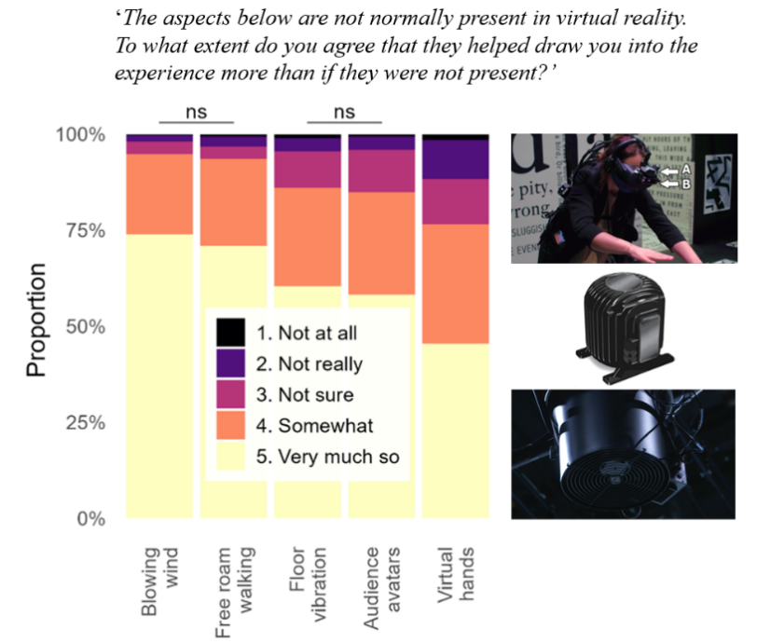
Left Figure: Depicting the frequency people responded with the different rating options to the question “The aspects below are not normally present in VR. To what extent do you agree that they helped draw you into the experience more than if they were not present?” Top-right Figure: HTC Vive Tracker used to locate head position precisely and Leap Motion controller for tracking hand position. Middle-right Figure: Illustration of a bass-shaker used to generate experience vibration. Bottom-right Figure: Rig-mounted fan. Adapted from © A. Woods et al., 2025. Going Beyond the Ordinary — User Perceptions of the Impact of Multisensory Elements on Presence in Virtual Reality at the Royal Opera House (Author Accepted Manuscript, Royal Holloway Research Portal, used under CC BY).
“Simple physical cues, like wind and free movement, do a lot of heavy lifting for presence, but to really make them impactful, they need a clear, direct connection to focal elements in the scene. The takeout is how much context/motivation for an effect matter. In [another experience], the vibrating floor was used to amplify the effect of travelling on a monorail and that was a real standout moment for the majority of our users. My feeling is that [multisensory elements] often play their part in a greater-than-the-sum-of-the-parts equation. One of the wonderful things about these sensory effects is that they are generally, relatively lo-fi and therefore, relatively cost-effective. In fact, one of the best sensory effects we ever delivered was some gravel glued onto hardboard. Stepping on that natural texture when walking into a (virtual) exterior space gives a huge boost to immersion but costs a few pounds to deliver.”
— Simon Reveley, CEO at Figment Productions
The findings reinforce a broader principle: presence flourishes when multisensory signals are plausible, well-timed and narratively relevant.

Practical insights

Latency tolerances
It is popular to benchmark creative technical solutions in terms of quality of service⁴⁷, which encompasses computer science related terms such as bandwidth, jitter, packet loss and latency. Audiences on the other hand are concerned with the quality of experience⁴⁷, encompassing subjective terms such as smoothness, responsiveness, comfort and immersion.
These two do not always align. Solutions that technically fall short in terms of strict quality of service thresholds can sometimes still deliver a satisfying experience if they remain within perceptual tolerance windows. On the other hand, despite meeting quality of service thresholds, something might feel just off about an experience without careful thought to multisensory elements. This distinction helps guide where creative effort and technical effort are best invested.
It is often difficult to ensure that information being presented to different senses arrives at exactly the same time. Fortunately, in integrating sensory information our brains can tolerate small mismatches in timing. This means that absolute zero-latency is not always necessary for an engaging, comfortable experience. The graph below illustrates the lags that can be tolerated for different tasks and information type.
[CHART-DATA: latency-tolerance]
Group | Label | Value (ms) | Error (ms) | Threshold
Collaborative music | Pro drummers introduce delay for music ‘feel’ ⁴⁸ | 1 | 0 | Acceptable
Collaborative music | Play to ear music e.g., jazz and rock ⁴⁸ | 7.5 | 2.5 | Acceptable
Collaborative music | Musicians^{49,50} | 25 | 0 | Acceptable
XR | Motion to Photon^{51,52} | 20 | 0 | Acceptable
XR | Tactile to visual⁵³ | 55 | 0 | Acceptable
XR | Tactile to audio⁵³ | 25 | 0 | Acceptable
TV | Audio ahead of video⁵⁴ | 45 | 0 | Acceptable
TV | Video ahead of audio⁵⁴ | 125 | 0 | Acceptable
Speech | Speech over mobile phone⁵⁵ | 150 | 50 | Acceptable
Speech | Own speech⁵⁶ | 1 |  | Not noticeable
Speech | Speech, person to person, 2m apart⁴⁸ | 6 | 0 | Not noticeable
Speech | Speech, person to person, 10m apart⁴⁸ | 30 | 5 | Not noticeable
[LEGEND] | Key latency tolerances for multisensory experiences. The graph shows approximate tolerated time delays and imperceptible time delays across a range of activities including motion-to-photon latency in gaming remote collaborative performance live music streaming and everyday sound propagation. Error bars show that several studies have been undertaken for a given activity and that their reported time delays do not match exactly. Note that XR stands for eXtended Reality.
[/CHART-DATA]
- Motion-to-Photon Latency in Gaming: When a player moves their character, a traditional view is that there should be a minimal delay before this movement is reflected on screen. This delay is known as motion-to-photon latency. Studies on first-person targeting and competitive FPS play show that reducing local latency improves performance; performance differences are already measurable in the tens-of-milliseconds range^{57,58}.
- Remote Collaborative Performances: When actors or musicians collaborate from different locations on the map, delays in audio and visual transmission can disrupt the natural flow of interaction, which can influence the quality of their performance and expressive nuance⁵⁹. In networked music performance, 20–30 ms is often cited as a target that feels close to in-person playing, although tolerable delay depends on repertoire, rhythm and performer adaptation⁴⁹. That being said, large orchestras, spread over a 40ft area (12.2m), would have delays of 35–36 ms milliseconds due to speed of sound, implying that there are workarounds to this issue⁴⁸. Out of curiosity, it is worth noting a striking parallel: the band AC/DC often performed within a few feet of each other, with Malcolm Young (rhythm guitar), Cliff Williams (bass) and Phil Rudd (drums) positioned very close and maintaining their famously precise rhythmic tightness: “They didn’t just play in time, they felt the time — the groove — together.”⁶⁰
- Live Music Streaming: When streaming a live music performance into viewers’ homes, it is important to consider how latency affects the experience. A small mismatch between audio and video can be tolerated, but the acceptable limits depend on which signal leads. For broadcast-style audiovisual sync, viewers begin to detect mismatch at roughly 45 ms when audio leads video, and 125 ms when video leads audio.
- Speed of sound: Sound travels through air at approximately 343 meters per second, meaning it takes about 2.9 milliseconds to travel 1 metre. If you sit 10 metres from a stage, you will hear the performer about 29 milliseconds later than someone in the front row. Temperature also has a significant effect: the speed of sound increases by around 0.5–0.6 m/s for each 1°C rise in air temperature⁶¹, with smaller contributions from humidity and air pressure. High frequencies are more dampened than lower frequencies, leading to a loss of brightness over distance. Here’s an interesting thought: if a performer’s mouth occupies about 2 cm in your visual field at 1 m but only 0.2 cm at 10 m (simply due to physics), lip-sync errors may be less perceptually obvious at that distance — but timing differences in sound remain important. This is one reason large venues and festivals strategically distribute speakers (delay towers) to keep sound aligned across the audience area. A known issue is that audience members located between two towers may hear slightly misaligned signals, creating a hollow or echo-like effect. Much of the craft of setting up public address systems involves tuning these time delays and shaping directivity patterns to minimise overlap and interference^{56,62}.
Tolerances also vary substantially from person to person. For example, children typically have a higher tolerance for audiovisual delays than adults⁶³, people with Attention Deficit/Hyperactivity Disorder (ADHD) tend to have a lower tolerance⁶⁴ (narrower windows; note some recent counter evidence exists⁶⁵), and individuals with developmental dyslexia⁶⁶ or with schizophrenia⁶⁷ generally display higher tolerances (broader windows) for the same lags. Because inclusive design should cater for all, including the most sensitive groups, latency budgets ought to be set just below the smallest empirically reported window, even if larger windows appear acceptable for other audiences.

Tolerance of spatial mismatches
When sensory signals appear in roughly the same location, our brains tend to merge them. Interestingly, this principle can hold even if there is a small but noticeable gap. For example, in a ventriloquist’s performance the puppeteer’s mouth is the true source of sound, yet onlookers often perceive the puppet itself as talking⁶⁸. Even when there is a 30° separation⁶⁹ between the puppet and the ventriloquist’s mouth, observers often fuse the two. A variety of factors influence the level of acceptable variation, as outlined in the next section.

Prior experience and the assumption of unity
If we believe that two signals share the same origin, our brains can tolerate more pronounced mismatches in timing or location than usual. Early work⁷⁰ showed that simply expecting signals to come from one source can override some discrepancies in timing or location. This is known as the assumption of unity and it is strongly influenced by prior experience – the brain learns from repeated multisensory encounters, building strong associations that guide whether future signals are integrated.

The Face on Mars captured by NASA’s Viking 1 orbiter in 1976. This image is often cited as a classic example of pareidolia: the human tendency to perceive meaningful patterns, such as faces, in random or ambiguous visual data. © NASA/JPL, Viking 1 Orbiter, 1976.

Perceptual ‘filling in’
Our brains often fill in missing or messy sensory data, drawing on past knowledge and context to create an experience that is fuller than that of the sensory information provided. An example of this is pareidolia, the tendency to see meaningful patterns in random or ambiguous things. This is why we might see a face on the surface of the moon or a human figure in the shadows on a dark street⁷¹. This ability to interpret incomplete sensory information is essential for navigating the messy reality of everyday perception. And it also offers creative opportunities. In particular, it points to the conclusion that not every detail needs perfect simulation. Strategic hints can prompt audiences to imagine the rest, easing technical demands without sacrificing immersion.

Multisensory attention
Multisensory cues are excellent at attracting and holding attention. Hearing a loud bang alongside a bright flash is more attention-grabbing than either of these alone. And in a performance or interactive exhibit, coordinating sound, light and even gentle tactile cues can effectively steer the audience’s focus.
Attention can also be drawn by sensations which violate our expectations⁷². This suggests that deliberate deviations from multisensory realism could be used to capture people’s attention in interesting ways, where objects may appear to be made of one material but feel unexpectedly different to the touch (e.g., a surface that looks like hard stone but is actually soft), thereby creating surprise and increasing user interest or engagement.
Once attention is focused on a particular event, it has a number of other important effects. For example, attention can enhance multisensory integration, amplifying effects such as the ventriloquist effect discussed earlier⁶⁸. Attention can also selectively amplify some stimuli while suppressing others. The cocktail party effect is a classic example whereby you can often tune out background noise to focus on a single conversation⁷³. Interestingly, attending to lip movements in a noisy room has been found to make a speaker’s voice perceptually louder, roughly the same as a +5 dB increase in sound level or about 150% of the original loudness⁷³. And this amplification effect occurs in the other senses as well⁷⁴, for example heightening visual contrast⁷⁵, or making flavours seem richer or more pronounced⁷⁶.
Attention directed toward emotional stimuli can also heighten affective responses, making emotionally charged experiences more intense⁷⁷. Whether it’s focusing on a beautifully plated meal or a dramatic moment in a film, attention can amplify the depth of an emotional experience by prioritising and enhancing relevant sensory cues.

Holistic experiential integration
Audiences absorb far more than just the main show. From their first step into a venue, the lighting, ambient sounds and even the scent of the lobby, all shape their overall impression. Subtle touches, like a textured ticket or a gentle aroma, can make a lasting emotional impact. This highlights the importance of carefully designing the onboarding and offboarding phases of an experience (the whole arc³²) to ensure it feels inclusive, enjoyable and comfortable for everyone⁷⁸ .

In focus: Vision
The increasing availability of very large, high-resolution light-emitting diode (LED) screens is transforming our built environments, production processes and entertainment experiences. At the same time, continuing developments in VR and Augmented Reality (AR) visual presentation techniques are introducing new possibilities for immersive experiences and Mixed Reality (MR). The dominance of visual media is therefore set to continue and for good reason: vision plays a central role in most people’s experience of the world.
Perhaps one of the most well-known screens is the Sphere in Las Vegas, which opened in 2023^{79,80}. It’s the world’s largest spherical structure (17,600 seats) with a 15,000m², 16K wrap-around LED screen. It includes an immersive sound system with approximately 167,000 speaker drivers, 10,000 haptic seats , wind, temperature and scent effects. Its debut concert, U2:UV Achtung Baby Live at Sphere, blended live music with reactive digital environments. An external facing screen, known as the exosphere, transforms the structure into dynamic animations for art and promotion.
In London, the Outernet is a free-to-enter, public walkthrough entertainment area based in the Now Building, a four-storey-tall structure wrapped in wall to ceiling high-definition LED screens with spatial audio. Content includes digital art, live broadcasts and immersive branded experiences. Outernet sometimes incorporates multisensory elements such as motion-responsive lighting installations, phone-triggered collective soundscapes and atomised scent.
Together, these examples highlight how large-scale visual technologies are being paired with other senses to reshape expectations of immersion in both public and ticketed settings.
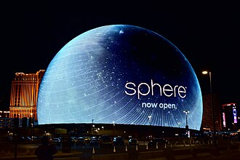
The exterior of the Sphere in Las Vegas. © Y2kcrazyjoker4, 2024.

Case study: Abba Voyage
Opened in May 2022, ABBA Voyage is a landmark virtual concert residency staged in the purpose-built ABBA Arena (3,000 capacity) at Queen Elizabeth Olympic Park, London. The show blends de-aged (by 40+ years) sometimes 10-metre-tall digital avatars (ABBAtars) of the band with a 10-piece live band performing on stage⁸¹. ABBAtars were created with performance capture and visual effects by Industrial Light & Magic. Sound is delivered through an L-ISA system with 291 surround speakers.
The performance is hybrid, combining pre-recorded, rendered ABBAtar performances alongside live musicians. There is a tight choreography between both sets of performers, generating a strong sense of liveness and presence⁸². The ABBAtars are displayed on a high-resolution LED screen and transparent staging elements, with carefully controlled lighting. It has been argued that such performances can still be experienced as live, even when the performers are digital and pre-programmed⁸³.
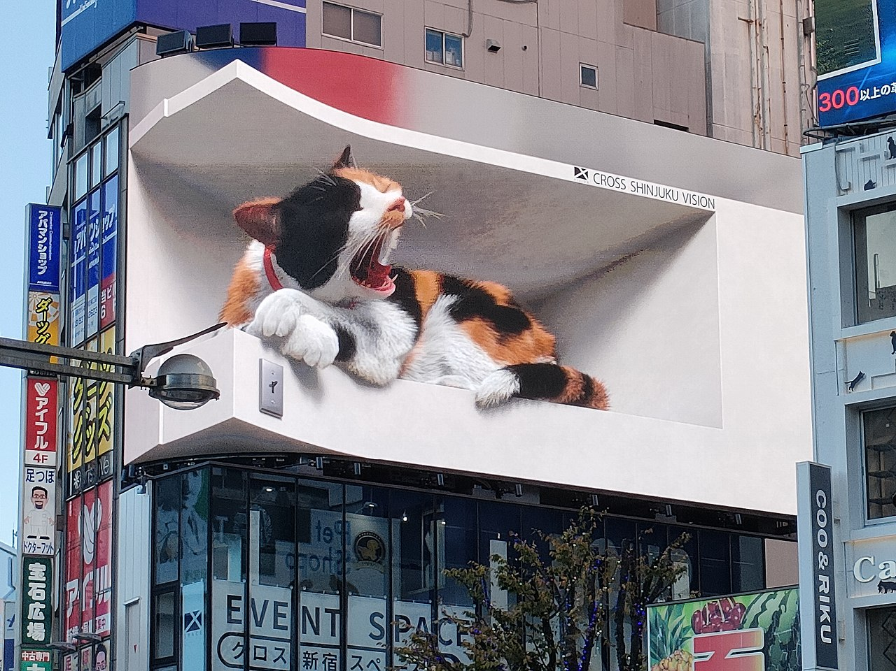
3D digital signage at Shinjuku train station. © Suicasmo, 2021, CC BY-SA 4.0.

Case study: 3D digital signage, Shinjuku train station (Tokyo, Japan)
Since 2021, a giant hyper-realistic 3D cat has been captivating passersby above the Shinjuku train station in Tokyo, not only because of its cuteness but also thanks to the anamorphic visual illusion of depth. The calico cat naps, stretches and plays in a way which, thanks to the curved 4K LED screen, makes it appear to be stepping out of its digital home⁸⁴.

Practical insights

Flicker
Perceived flicker in visual displays can be uncomfortable for viewers. It can also reduce the sense of realism and, therefore, immersion in virtual environments. People can typically detect flicker at frequencies up to around 60-77 Hz⁸⁵.

Light and dark adaptation
Our eyes adapt to the dark over time, with most adjustment happening in the first 5 to 10 minutes, and full adaptation taking up to 30 minutes. As our eyes adapt, we see less colour and rely more on differences in brightness and contrast. Slightly higher light levels or careful lighting can preserve some colour without sacrificing the immersive feel of darkness.

Visual illusions
Our visual system can be tricked by a range of illusions, some of which offer interesting creative opportunities.

- Forced perspective: Our brains interpret visual size and distance based on context. For example, we know from experience that objects at a distance appear smaller. The forced perspective illusion tricks this aspect of visual perception through the strategic placement of objects and the viewing angle to make items appear larger or smaller, or at different distances, than they actually are. In The Lord of the Rings films, director Peter Jackson offset actors in depth but hid this difference with carefully duplicated props to make hobbits appear half-sized. The hobbit character would sit further away from the camera than the non-hobbit, with props such as benches and tables merging flawlessly in camera to hide the cues that would normally help us notice these differences in depth. This way, the actors’ scale was changed via optics, not in post-production.

- Hollow-face illusion: An inverted (concave) face mask, viewed from the front, is interpreted as a normal face that eerily appears to track the observer as they move. The illusion works under modest lighting and when viewed from 1.3m⁸⁶ and beyond, making it a low-cost way to add an unsettling presence to galleries or stage backdrops.

- Pepper’s ghost: An angled sheet of glass can be positioned to reflect a hidden, brightly lit performer or projection, creating the illusion of a lifelike ghost appearing among live on-stage actors. From Victorian parlour tricks to the present day, this technique has been key to hologram-style stagecraft⁸⁷.

- Illusory contours: The brain often fills in visual lines or edges where these are implied, even if they are not fully depicted. For example, in the figure below, most people perceive a white triangle sitting on top of another triangle and three black circles, even though this white triangle is not drawn.

Illusory triangle: Three pac-man discs and three corner bars induce the perception of a bright white triangle, with crisp edges and apparent occlusion, despite no triangle being drawn. © Fibonacci, 2007, CC BY-SA 3.0.

Inclusion considerations

Colour blindness and low vision
Roughly 1 in 12 men and 1 in 200 women experience some form of colour blindness⁸⁸ worldwide. In the UK, 1 in 5 people will experience sight loss at some point⁸⁹. To support greater inclusivity, use high-contrast colour palettes, offer the option to adjust text size and select different fonts, including dyslexia-friendly fonts and provide visual indicators that do not rely solely on colour (e.g., by employing distinct shapes or textures). Whenever possible, offer alternative formats to access visual information. There are numerous sources^{90,91} that provide practical recommendations on designing for users with low vision or colour blindness.

Lighting and brightness
Bright lights or high-glare visuals can be overwhelming for some individuals, including those with migraines or photosensitivity. Providing adjustable brightness levels or offering darker night-mode display options can help mitigate discomfort.

Motion sensitivity and flicker
Rapid on-screen movements and flicker effects may trigger discomfort or photosensitive epileptic seizures. Offering reduced-motion or static display options and ensuring critical content is not lost if motion is disabled, can help users remain engaged without health risks.

Cognitive load and simplified layouts
Overly dense or cluttered designs can create cognitive overload. Offering simpler focus modes or letting users hide non-essential visuals and text can help reduce cognitive load.

In focus: Hearing
Sound plays an important role in shaping our experience – a horror film without sound feels a lot less scary⁹². Recent VR-horror games with realistic ambient sound have shown almost double the self-reported fear levels by comparison with silent conditions⁹³. Rapid recent advancements in 3D audio and beamforming technology (for directing sound to specific locations) can also unlock exciting creative opportunities for immersive experience and spatial sound designers.

Case study: Arcade
DARKFIELD are renowned for their innovative use of binaural sound in complete darkness. Usually located inside a shipping container, their experiences locate stories in space with an innovative use of audio, expanding our understanding of the importance and potential of sound for storytelling.

Arcade is a 25-minute, choose-your-own-path experience run in pitch-blackness. Wearing noise-isolating headphones, participants are guided solely by a 360-degree binaural soundtrack whose branching narrative responds to a button press and coins inserted into a cabinet’s slot. Arcade also incorporates additional sensory elements such as sudden splashes of water (see Case study: water droplets) and 3D-printed props.
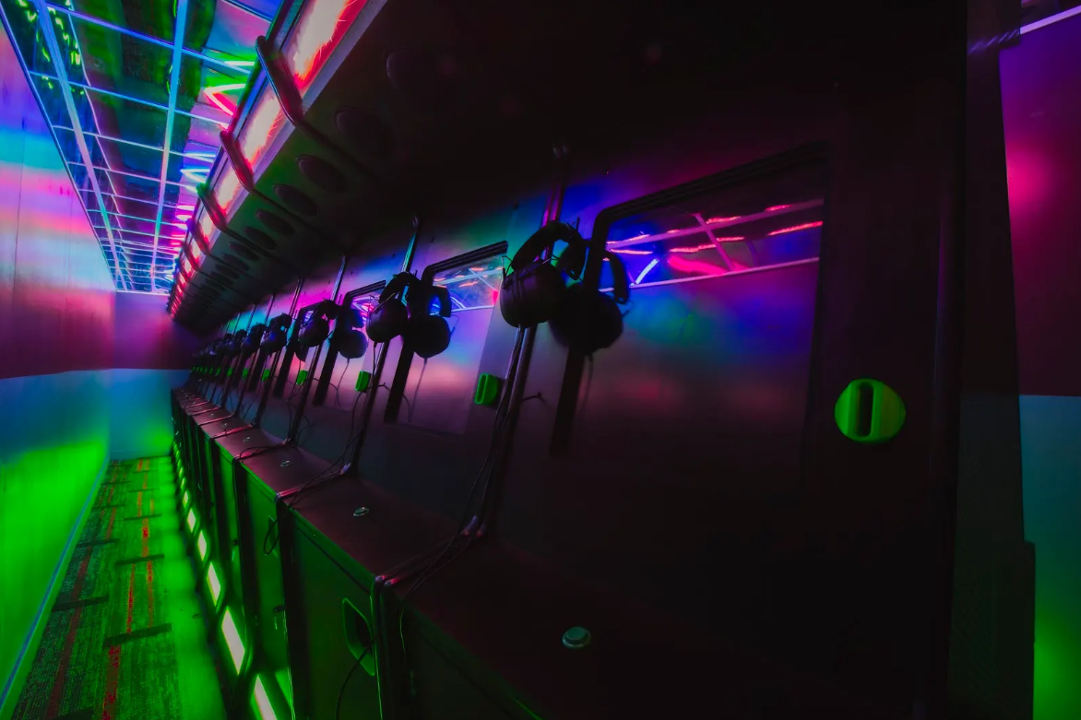
DARKFIELD’s ARCADE, Nottingham Lakeside Arts. Neon-lit interior with a row of arcade cabinets and over-ear headphones inside a shipping-container installation. © Katie Edwards, 2024.
“When we begin thinking about a new show we always think about what new multisensory elements we can explore. Our work is less interested in a traditional narrative structure and the special effects we use are as integral to the story we tell as the script.”
“Because of the branch narrative structure of Arcade, it was clear that any sensory events needed to be individual to each audience member (in all our other shows the effects are universal to everyone). Often the smallest effect can have the biggest impact, the water spray in Arcade is the one that most people mention. It's important though that any effect we use is integral to the story; its primary function is to augment the audio.”
— Glen Neath, Artistic Director and co-founder at DARKFIELD

Practical insights

Low spatial resolution
Both ears are required to determine the source of a sound, a process the brain carries out by comparing the signals received at each ear. A sound will be perceived more loudly in, and reach fractionally earlier at, the ear that is closer to the source. These cues allow the brain to identify the broad direction of the sound. However, this process often delivers a range of possible solutions, producing a range of potential locations known as the cone of confusion. Because of this relatively imprecise ability to localise sound, we frequently rely on vision (which generally operates at much higher spatial resolution) to decode a specific source of sound. For example, we may use hearing to turn toward the approximate direction of a sound source but then depend on visual information to pinpoint the exact source¹⁰.

Inclusion considerations

Hearing diversity
Not everyone hears the same way. Where possible, provide alternative channels such as captions, text transcripts and visual alerts, to ensure that core content and prompts are available to all.

Sound overload and sensory sensitivities
Some individuals, for example some people with autism, may find certain sounds, sudden noises, or loud environments overwhelming or distressing. Offering user-adjustable volume controls, sensory-friendly sessions, sound dampening headphones and ensuring access to a quiet space, can all help reduce sensory overload.

Spatial audio for orientation
Spatial or 3D audio can enhance immersion and assist navigation for those with limited vision. However, keep in mind that some people with hearing-impairment may struggle to localise sound. Providing complementary visual or tactile cues helps ensure that essential directional information is not lost.

In focus: Touch
The sense of touch plays a key role in interacting with the world, whether sensing temperatures, signalling pain, allowing us to hold and manipulate objects, or providing a route for social connection. Touch is also a complex sense: different receptors in the skin detect different qualities of touch, including pressure, vibration, stretch, texture and temperature.

Haptic technologies range from common vibration motors found in phones and game controllers (e.g., Sony DualSense, Apple Taptic Engine) and force-feedback devices like steering wheels. More advanced solutions include haptic vests that provide localised feedback for VR; full-body suits that deliver tactile sensations across multiple areas; and 4D cinemas that incorporate in-seat vibration, motion and even wind effects. Experimental approaches are also emerging, such as ultrasonic mid-air haptics, surface haptics that simulate screen textures and Electrical Muscle Stimulation (EMS), which uses low-level electrical impulses to directly evoke sensations of force or movement.
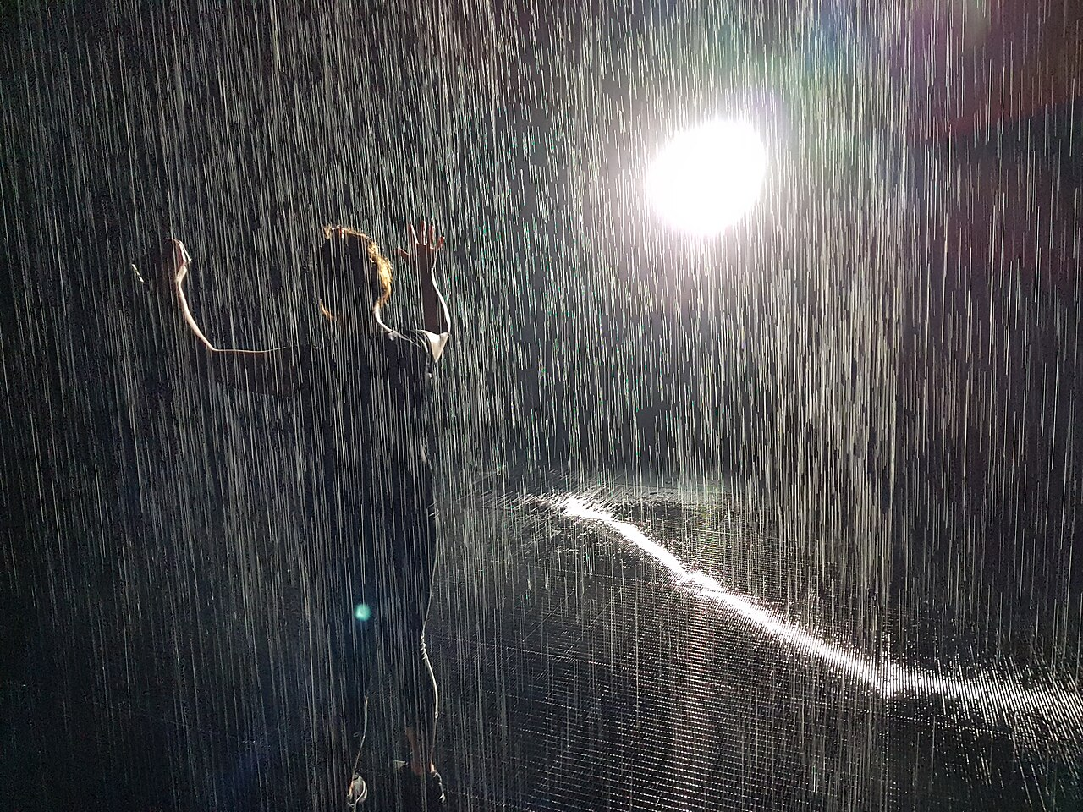
Rain Room, Sharjah Art Foundation (2018). Installation by Random International where visitors walk through simulated rainfall whilst remaining (mostly) dry. © Wikimedia Commons, licensed under CC BY-SA 4.0

Case study: Water Droplets
Various experiences such as 4D cinemas and theme-park rides project water to enhance realism. This use is also appearing in other more bespoke experiences. For example, Arcade (see Case study: Arcade) also incorporates sudden splashes of water when a nearby character is shot, to simulate the spray of blood. These can be delivered through simple nozzles that release a timed spray from a central reservoir (used in 4D cinemas and theme-parks), but there are other methods such as piezo atomisers to create a fine mist, peristaltic pumps to deliver a precise droplet burst, and air–water jets using compressed air to flick a small amount of liquid. Large-scale installations such as Rain Room⁹⁴ use a grid of computer-controlled ceiling nozzles supplied by pumps and recirculating water systems, with overhead tracking cameras to detect visitors and pause the rainfall above them, allowing people to walk through rain (mostly) without getting wet.

Case study: In Pursuit of Repetitive Beats
In Pursuit of Repetitive Beats, a VR film created by Darren Emerson, demonstrates how touch-based stimuli, delivered via haptic vests and environmental wind, can be incorporated into VR to elevate immersion. Set in 1989, In Pursuit of Repetitive Beats immerses its audience in the UK acid-house scene. In addition to the VR headset, participants wear a haptic vest which physically vibrates in sync with the music to replicate the visceral sensation of a rave’s pulsing beat. At times, a fan is activated to simulate the sense of being outside or driving in a car with open windows. Director Darren Emerson explains that the audience “can be in a specific physical location that has a fan so that they can feel the wind blowing on them as they're in the car but also as they're going into this cosmic space and dancing.”⁹⁵


Poster for Jeff Wayne’s The War of the Worlds: The Immersive Experience. © Layered Reality.

Case study: Jeff Wayne’s The War of the Worlds: The Immersive Experience
Produced by Layered Reality, Jeff Wayne’s The Ware of the Worlds: The Immersive Experience is a large-scale walk-through encompassing live actors, spatialised sound, holograms and various VR segments with realistic physical sensations. Across 24 scenes, tactile elements are used to help drive narrative. These include controlled vibration and motion cues for artillery fire and Martian machinery, cool and hot airflow to indicate outdoor chases and a heat-ray, and moments in which visitors physically crawl or slide.

Practical insights

Active and passive forms of touch
Scientists make a distinction between active and passive touch⁹⁶. In active touch, we move our hands or bodies to explore and manipulate objects; think of running your fingertips over a fabric to feel its texture. By contrast, passive touch occurs when an external stimulus is applied to us without our involvement, such as a spider running across our skin. Both forms of touch contribute to our overall tactile experience but engage different cognitive and motor processes.

Temperature
Temperature can be a powerful cue for enhancing immersion in a virtual scene. For example, Peltier cooling elements (which use an electric current to generate localised cooling as well as heating) added to a VR headset significantly enhanced presence in scenes depicting snow-covered mountains and desert canyons⁹⁷.

Localisation
Touch works together with proprioception (our sense of body position; see later section In focus: Proprioception and body map) and the vestibular system (which contributes cues relating to gravity and movement) to help us identify where on our bodies we’re being touched.

Social touch
Touch can carry significant emotional weight^{98,98}. For example, hugs, handshakes and gentle pats on the back can all communicate comfort or camaraderie. However, replicating these nuanced social touches digitally remains a significant challenge.

Current technical challenges
There are significant limitations with existing haptic technologies. Many wearable systems like suits and vests are bulky, restrictive and can cause discomfort or fatigue, potentially breaking immersion rather than enhancing it. Additionally, the sensations generated by many devices remain relatively crude, often relying on basic vibrations that lack the nuance of real-world tactile experiences, though user imagination can partially bridge this gap (see the earlier section on Perceptual ‘filling in’). Technical complexities also pose a major challenge, particularly achieving the precise, real-time synchronisation needed between haptic feedback and corresponding visual or auditory events; any noticeable lag or mismatch can disrupt the sense of realism more severely than omitting haptics altogether (see also the earlier section on Tolerance of spatial mismatches).

Inclusion considerations

Sensory and physical diversity
People vary widely in their tactile sensitivity and some may experience any form of touch as intrusive. Allowing users to personalise the intensity and pattern of stimulation, such as the rhythm, duration and spatial distribution of haptic pulses, can help mitigate this⁹⁸, as can providing explicit advance warnings when touch will be used in an experience.
Wearable systems vary widely in form, ranging from full-body suits to more localised devices such as bracelets, chest straps, gloves, headbands or trouser-based systems. Across these formats, devices should adapt to diverse body shapes, sizes and mobility levels. Currently, many commercial wearable suits are based on the average male body⁹⁹. For users with shorter statures, curved spines, wider hips or breasts, sensors and actuators can shift out of place, reducing feedback quality or creating unnecessary pressure points. Vibration can also be perceived as intrusive for some individuals. To help offset this, modular panels¹⁰⁰ with elastic lacing or velcro allow sleeves and torso sections to be adjusted independently around the hips, waist and chest.

Assistive opportunities
Haptics can be used to augment audio feedback, help people with spatial orientation and improve access for people with visual impairments. They can also provide an alternative route into rhythm and atmosphere for people who are deaf or hard of hearing. For example, Coldplay’s Music of the Spheres tour (2022–25), mentioned earlier, began offering wearable bass-responsive vests and vibration backpacks, allowing audience members to feel the bass and rhythm.

In focus: Smell
Smells can have a strong, often subconscious, influence on mood and emotion, as well as triggering powerful recollections. This strong link to memory is sometimes referred to as the Proustian effect, after a sequence in Marcel Proust’s novel In Search of Lost Time in which the narrator tastes a madeleine (a small French cake) dipped in tea and is suddenly flooded with long-forgotten childhood memories. Although this example focuses on the taste of the cake, flavour experiences of this type involve smell as well as taste; this is why people often find that food tastes bland when they have a cold.
Efforts to incorporate smell into experiences generally rely on computer-controlled scent-delivery systems. These devices release specific chemical odorants, typically stored in pre-mixed oils or cartridges, at precisely timed moments to synchronise with the experience. A promising emerging technology is to use modular piezo-electronic devices to vaporise odorants precisely without heat¹⁰¹. Alongside these established chemical-release methods, highly experimental research is exploring the direct electrical stimulation of olfactory receptors within the nasal cavity, aiming to evoke smell sensations without using physical odorants¹⁰².

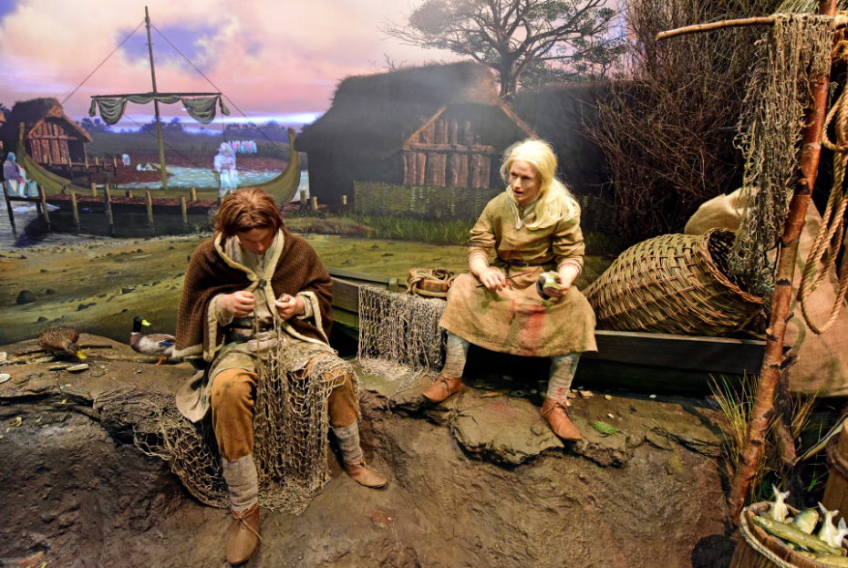
Animatronic fishermen tableau at JORVIK Viking Centre, where scent effects are used alongside the visual scene to evoke the smells of the Viking-age environment. © York Archaeology

Case study: Jorvik Viking Centre
The Jorvik Viking Centre in York, opened in 1984, has long been recognised for its pioneering use of multisensory design to bring history to life. Central to the experience is a ride through a reconstructed Viking settlement, complete with animatronic figures, sounds, visuals and distinct smells. The latter were delivered originally using scent pots but are now delivered via pipes from a centralised scent bank for ease of refilling. Smells are released at key points along the ride, which range from wood smoke and leather to fish and human waste. Several of the authors visited the museum as children and vividly remember the distinctive smells of the ride decades later. For them, the experience was exciting, at times even frightening, yet profoundly memorable. This highlights how multisensory design can create long-lasting impressions that endure well beyond the immediate visit. By blending sight, sound and smell in a tightly synchronised way, the Jorvik Viking Centre illustrates how relatively simple technologies, when applied thoughtfully, can transform education into an embodied, emotional experience.

Practical insights

Adaptation
We quickly adapt to individual smells, sometimes within 200ms¹⁰³, meaning that we might not notice a certain smell after it has been present for a certain amount of time. When incorporating smells into experiences, it might be helpful to plan for periodic changes.

Sensitivity
Human noses can distinguish thousands of odorants at very low concentrations, though individual sensitivity varies greatly. It was traditionally thought that humans could distinguish around 10,000 odours, but new research exploring combinations of odours puts this figure much higher, at more than a trillion¹⁰⁴. Surprisingly though, despite this sensitivity in distinguishing between smells, naming them appears to be something that many people find difficult in the absence of additional context from the other senses.

Context
Odour perception depends on context, temperature and humidity. A subtle scent in an open-air environment may become overwhelming in a confined space. In addition, higher temperatures increase the volatility of odour molecules, making smells stronger. Low humidity dries out the nose whilst high humidity slows evaporation of odour molecules, both of which are likely to degrade odour perception¹⁰⁵.
A well-known example of how context shapes odour perception comes from a neuroimaging study¹⁰⁶ where a cheese-like odour was presented to participants under the label cheddar cheese or body odour. This labelling strongly impacted how the brain responded to the odour, in regions linked with emotional processing and odour processing. In addition, people’s perception of the pleasantness of the odour fell sharply when the label read body odour compared with cheddar cheese. In another classic experiment¹⁰⁷, researchers took five chemically ambiguous odours and paired them with positive or negative descriptions, then asked participants to rate them. These included pine oil (paired with Christmas tree vs spray disinfectant), menthol (breath mint vs chest medicine), violet-leaf (fresh cucumber vs mildew) and patchouli oil (incense vs musty basement). Alternative labels swung pleasantness ratings by 1-3 points on a nine-point scale, again illustrating the significant importance of context in our odour experiences.

Current technical challenges
Current chemical-release systems are often expensive, rely on scent vials that need to be replaced regularly, and are limited in terms of the number of vials that can be handled (limiting the number of smells that can be released). Controlling the scent diffusion is also problematic: odours frequently linger long after their intended moment, which can be impactful when multiple people are doing different experiences in a confined area.

Inclusion considerations

Fragrance sensitivities
Research suggests that anywhere from 10% to 30% of the population experiences notable fragrance sensitivities¹⁰⁸, which include strong aversions to synthetic scents and can induce headaches or even respiratory discomfort. Note that the bread smell that some sandwich shops pipe into the air in front of their shops can be off-putting or even nauseating to these individuals. It is considered good practice to provide clear warnings, ensure good ventilation and offer scent-free alternatives or zones.

Impaired sense of smell
At the other end of the spectrum, some people have an impaired sense of smell and the likelihood of experiencing this seems to increase with age¹⁰⁹. For example, one study found that 24.5% of those older than 53 had an impaired sense of smell, compared to around 1.4% in the general population¹¹⁰.

In focus: Sense of space
Given that many experiences seek to transport audiences to new places, it is useful to consider how we build up a sense of the space that we are in, even though this is not traditionally seen as constituting a separate sense in its own right. Instead, our perception of space involves the integration of vision, hearing, balance (vestibular system) and the sense of body positioning (proprioception), allowing us to navigate, judge distances and layouts, and maintain posture and balance. The sense of space can also have a powerful influence on mood and emotional responses. For example, the experience of being in a vast, open simulated space¹¹¹ or large room¹¹² can inspire awe, compared to smaller areas.
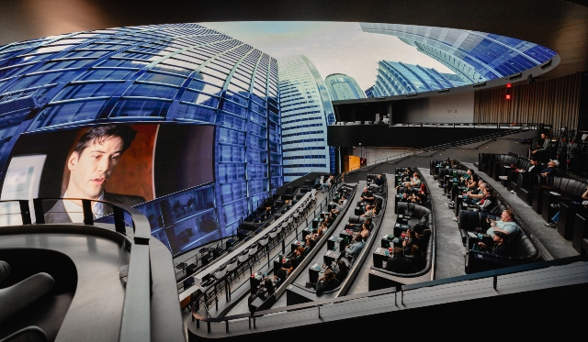
AW requested permission to use photo 27-2-26 photo for below case study. Reminder sent 18.3.26. Another reminder sent 28.4.26

Case study: The Matrix in Shared Reality
Cosm, an experiential media company that opened its first flagship venues in Los Angeles and Dallas in 2023–24, uses giant 87-foot LED domes with spatial audio to deliver what it calls Shared Reality experiences, blending cinema, live events and immersive environments. Cosm’s Shared Reality adaptation of The Matrix premiered June 2025 as a collaboration between Cosm, Warner Bros. and Little Cinema. The movie is shown in its original 16:9 frame, while the surrounding dome expands the world outward with, for example, office interiors continuing beyond the screen, bullets fly out of the frame, and during a helicopter rescue the skyline ripples and tilts in sync with the action.

Case study: Disney HoloTile floor
While VR can visually extend our sense of space, physical movement in those spaces is often restricted, relying on teleportation interactions or visual movements without corresponding body movements, which can be disorienting or cause motion discomfort⁶². Disney Imagineering provide an interesting way of extending physical space with the HoloTile^{113,114}, an omnidirectional modular treadmill floor. The floor enables endless walking due to the hundreds of independently rotating tile-like disks, which counteract the user’s movement and redirect them towards the centre of the floor, regardless of their direction of walking. With this, HoloTiles can create an illusion of endless space and movement within a physical as well as virtual environment, which could have fascinating creative implications.

Practical insights

Presence
A convincing sense of space is crucial for establishing the sense of presence or being there, particularly in virtual environments^{115,116} (see section Creative opportunities: Boosting ‘presence’).

Spatial illusions
Our understanding of space is highly malleable and therefore susceptible to alteration. Spatial illusions can be used to intentionally distort virtual or physical layouts to make tight areas seem larger, or vast spaces appear more intimate. In VR and AR, by providing the right kinds of visual and auditory feedback, a small studio can feel like a sprawling landscape, or a lifeless corridor can transform into an immersive fantasy realm. The effectiveness of these illusions relies on the brain’s assumptions about geometry, proximity and movement, revealing how easily we can be tricked into perceiving spaces that aren’t really there. For example, in one VR study^{117,118} whenever an opaque door blocked the user’s view, the system silently pivoted the adjoining corridor by 90°. Only 1 of 77 users detected this switch, showing how easily vision, proprioception and vestibular cues can be re-aligned to turn a small lab into a much larger building. Follow-up work on impossible spaces found that rooms can overlap by up to 56%, letting a 100-metre mansion fit inside a 9 m × 9 m tracking area without anyone noticing.

Inclusion considerations

Motion sickness and comfort
Technology that manipulates people’s sense of space can cause discomfort or nausea, with VR sickness being a particularly salient example. Despite best efforts to align sensory inputs (e.g., matching visuals to vestibular cues), even minor delays between head movement and visual can create sensory discrepancies that the brain interprets as disorienting (delays of 20ms or above¹¹⁹). Providing user-controlled personalisation settings, allowing for a period of adaptation, avoiding contradictory sensory signals and incorporating regular breaks, can all help mitigate these effects.

In focus: Personal and peripersonal space
Immersive media and live cultural events influence the bubble of space we inhabit and the distances we keep from others. These spatial boundaries are not fixed, they influence how intimate an encounter feels, how much tension is conveyed and how comfortable audiences remain in a crowd. The same principles apply whether someone is meeting an avatar in Extended Reality (XR), sitting in a packed cinema, or dancing at a festival.
Interactions range from one-to-one encounters (face-to-face with an actor or virtual agent) to group co-presence (audience seating, queues, crowd flows) to non-human intrusions (objects, lights or effects that enter the near-body zone). Understanding interpersonal space (the socially negotiated distance between people) and peripersonal space (the near-body region where the brain integrates vision, touch, proprioception and threat cues) offers creators a vocabulary for designing with these considerations in mind.

Case Study: Managing the bubble in onboarding
Laryssa Whittaker⁷⁸ explored how onboarding and offboarding shape audience comfort. At a Limina Immersive Cinema pilot in Bristol, careful attention was given to personal space: soft furnishings, low lighting and roped-off areas created a sense of safety before headsets went on. Audiences were asked how they preferred staff to signal attention, for example, by a consented to gentle tap on the shoulder. By contrast, a festival screening without seating or clear boundaries left participants sitting on the floor in public view, tethered by cables, and uncomfortably aware of strangers moving around them.

Practical Insights

Interpersonal space
Interpersonal space can be thought of as the socially negotiated gap we keep between ourselves and others. Several bands have been proposed¹²⁰: intimate (< 0.5 m), personal (0.5 – 1.2 m), social (1.2 – 2.1 m) and public (> 2.1 m). These boundaries vary¹²¹ depending upon culture, relationship status, crowd density and task. For example, East Asian norms tolerate closer proximity than Northern European. In immersive environments, a consideration of interpersonal space can be important for issues such as comfortable avatar spacing¹²² and queue management⁷⁸.

Peripersonal space
Peripersonal space has been referred to as the “multisensory interface between the individual and environment.”¹²³ It’s an invisible bubble of space, perhaps extending 60cm from the body, in which the brain processes objects/events differently from those farther away¹²⁴. Within this space the brain continuously fuses vision, touch, proprioception and threat cues to guide reaching, manipulation and self-protection.

Inclusion considerations

Diversity
Not all users are comfortable with the same interpersonal distances. Creators could provide adjustable avatar proximity tiers allowing people to tune their comfort radius.
Some people are put off experiences if they know in advance that there is no way of avoiding social interaction¹²⁵. Consider adding ways of letting users do your experience separated from others and make this feature obvious to users beforehand. In the case of VR, you could consider booths or a roped off section.

Peripersonal space sensitivity
Surprise intrusions into this space can trigger defensive reactions. Where close approaches are part of the experience (e.g., looming objects, intimate encounters), offer opt-in gradual motion, soft sound cues or haptic forewarning. Provide preview clips, clear opt-out points and staff support.

In focus: Interoception
Interoception refers to the sense of the internal states of our bodies: everything from feeling one’s own heartbeat, breath, hunger and thirst to visceral sensations such as butterflies in the stomach or fullness after eating. Interoception is intrinsically linked to emotion: perceiving a rapid heartbeat can amplify feelings of excitement or fear, while steady breathing often promotes calm. In fact, according to some theories¹²⁶, our emotions themselves arise as a result of interpreting these bodily signals. However, awareness of these internal signals varies significantly between individuals; some readily detect changes in their heartbeat or stress levels, whereas others notice very little.

Recent developments in wearable devices give people easy access to information about their internal bodily processes, such as heart rate and breathing patterns, as well as offering a range of interesting creative opportunities. Some emerging technologies^{127,128} can even estimate heart rate and respiration from live video footage, though this typically requires the person being recorded to remain still.

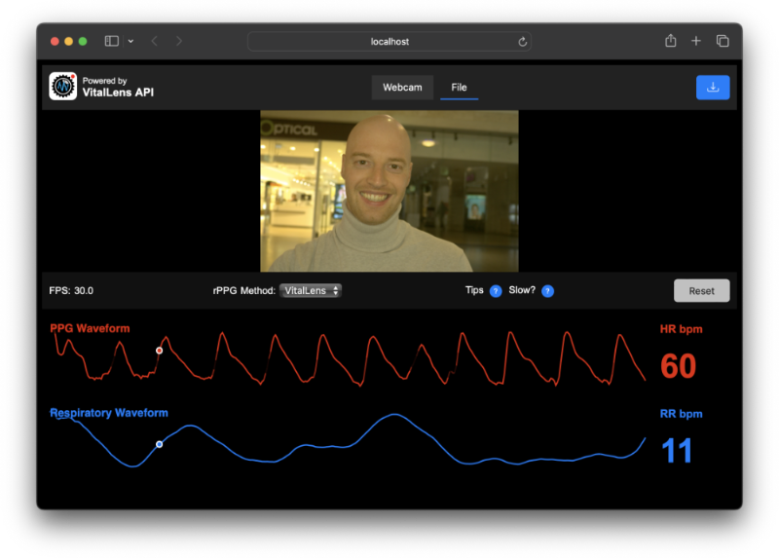
Browser-based remote photoplethysmography (rPPG) demo estimating heart rate from live facial video via real time subtle skin-colour change; runs entirely in-browser¹²⁹. Image shows live webcam feed and estimated heart rate. Demo. © P.V. Rouast / Rouast Labs.

Practical insights

Boosting true bodily signals
Experiences that bring our real bodily sensations more effectively to our awareness may be able to support physical and emotional regulation. For example, heartrate and breathing monitors are often used to provide feedback to participants in relaxation-focused experiences.

Creating illusory bodily signals
It is also possible to create interoceptive illusions, for example by providing a haptic or audio heartbeat (e.g., a heartbeat sound or pulse-like vibration). If the illusion is convincing, timed closely enough to the real pulse, people can think that the artificial rhythm is their own, and this can in turn modulate their emotional state (e.g., increasing fear by portraying a rising heartrate, or promoting calm through simulated slow, steady beats¹³⁰).

Inclusion considerations

Individual differences
Amplifying interoceptive signals can increase anxiety or be uncomfortable for some. In addition, many people do not experience strong interoceptive sensations, so experiences that are overly dependent on subtle interoceptive cues may not work well for these audience members.

Data protection
Biometric data can be highly sensitive. For example, heartrate monitoring may reveal abnormalities that a participant may not yet be aware of and that onsite staff may not be trained to handle. User consent and data privacy considerations are critical.

In focus: Proprioception and body map
Our proprioceptive system constantly tells us where each limb is and how the body is arranged; the body schema is the brain’s running model of that information. In VR, AR and MR, this map is surprisingly pliable – sight, touch and movement cues can nudge it to accept new limb sizes, extra joints or even a completely different body.

Case Study: Body of Mine
In the award-winning full-body-tracked VR experience, Body of Mine by Cameron Kostopoulos¹³¹ (SXSW 2023, Venice Immersive 2023), users step into an avatar of a different gender. Live head, hand and eye tracking ensure movements line up, while first-person audio from trans interviewees is delivered through spatialised sound, tightening ownership of the borrowed body.

Practical Insights

Masking bulky haptics gear
Synchronous visual–tactile cues, such as those used in rubber-hand illusions (see the Crossmodal illusions section for details), can shift perceived limb position by several centimetres in under 60 seconds³³. At the whole-body level, the effect is even greater: just 60 seconds of synchronously stroking someone’s back whilst also being seen (by the person) to stroke an avatar’s back can displace perceived self-location by up to 24 cm toward the avatar¹³². Deliberate visual–motor mismatches, such as making a hand appear to rotate 30 degrees more than in real life, are typically adapted to within minutes¹³³, reflecting the sensorimotor system’s rapid recalibration capabilities. This demonstrates how quickly the sensorimotor system can recalibrate. This plasticity could potentially help hide the physical constraints imposed by bulky haptic devices, given sufficient time is given for adaptation.

Influencing strength
Being given a different body or having your physical size manipulated in immersive experiences can change how people judge effort and what seems physically possible. In such situations, your body acts like a perceptual ruler, with objects in the virtual environment, distances and actions undertaken being perceived quite differently, sometimes differently from how they feel in reality. A consequence is that some interactions might feel easier or harder, and the realism of how objects behave can seem different depending on the perceived body size or identity¹³⁴.

Technical challenges
Consumer grade trackers remain vulnerable to occlusion and can drift by approximately ±2 cm. Adding Inertial Measurement Units (small sensor packages containing accelerometers, gyroscopes, etc.) or using inside-out tracking (outward facing cameras on VR headsets) can reduce the errors, but these can increase system complexity¹³⁵.

Inclusion considerations

Proprioceptive diversity
Ageing, stroke and conditions that affect sensory or motor function can all distort our sense of limb position. Personalisation can help keep interactions comfortable. For example, allow users to adjust motion-gain (the ratio between their real movement and the avatar’s) and provide clear, high-contrast outlines of virtual limbs so visual cues can compensate for reduced proprioceptive and motor acuity (see the section on Plasticity).

Sensory mismatch
Sensory mismatch can induce nausea, dizziness and lingering disorientation. Adaptation periods can help. Provide content warnings, preview videos, opt-out points, clear exit routines and seated decompression recovery zones⁷⁸.
In virtual production, actors can fall over with background shifts. Bill Burr (the actor who played Migs Mayfield in the Mandalorian) said: “If the camera moves behind me, the stuff behind you moves, you get like, vertigo. So that's why I think the acting in those scenes is really good - you have to lock in on the actor because if you start looking at the other stuff you're gonna tip over”¹³⁶.

In focus: Interactivity
Interactivity is often seen as a key feature of immersive and multisensory experiences, and it can take many forms. Audiences may engage through physical movements such as gestures, eye-movement, speech, touch or full-body motion, through social interactions with other participants, live performers or virtual avatars, or via technologies including controllers, sensors, wearables and smartphones. The environment itself can also become interactive, with sound, light, vibration or objects responding dynamically to audience presence. These interactions can occur at different levels, ranging from subtle ambient feedback (such as lighting, sound or vibration that responds to movement) to collective audience-wide participation, and to branching narrative choices that alter the story. Ideally, interactivity shifts audiences from passive spectators to active co-creators. However, inclusion remains essential: not everyone desires or enjoys the same degree of interactivity; experiences should offer multiple pathways that are both accessible and adaptable.

Case study: Brainstorms
An interesting example of the creative engagement with internal bodily signals is the Brainstorms: A Great Gig in the Sky (2024) installation, produced by Pollen and curated at London's Frameless gallery. The experience visualises the audience’s real-time brainwave data while listening to Pink Floyd through the use of EEG caps that measure their neural activity. This experience allowed people to view creative projections of their brain’s real-time reactions to the music as shifting aurora-like skies, star murmurations or glowing neural clouds. Audiences reported feelings of emotional connection with their brainwaves and a sense of self-awareness¹³⁷.

Practical insights

Full-body real-time motion capture
Robustness is key: ensure that the loss of any single channel, does not significantly degrade the experience. For example, Taylor Swift’s Eras Tour (2023–24) used PixMob wristbands with coloured LEDs controlled via infrared, turning the audience into a low-resolution visual display. If that infrared signal is blocked or disrupted (be it due to an audience member standing behind a tall person), the effect may be weakened for some audience members. It is also important the technologies remain reliable under long term, repeated usage.
With multiple audience members, priority becomes a consideration. Does the first gesture win, or are gestures aggregated across audience members? Is there a central location where someone can override inputs?

Physiological data
Data needs to be ephemeral and not stored, unless visitors have given explicit permission for research or marketing use. Treat physiological data (e.g., heart rate) as sensitive and obtain explicit, informed consent; also provide opt-out and deletion routes.

Inclusion considerations

Alternate channels
Interactivity should not be based on a single sense or ability. Providing a range of alternate inputs, such as gestures and physical inputs (perhaps via smartphone, thus permitting aid from assistive technologies) allows individuals with limited mobility or speech to still trigger pivotal moments.

References
1. VML Intelligence. Welcome to the Age of Re-Enchantment. https://www.vml.com/insight/the-age-of-re-enchantment-report (2023).
2. Ofcom. Children’s Passive Online Measurement. https://www.ofcom.org.uk/siteassets/resources/documents/online-safety/research-statistics-and-data/protecting-children/ofcom-childrens-passive-online-measurement.pdf (2025).
3. of London Theatre, S. & Theatre, U. K. The State Of British Theatre In 2025: Growth, Risk And The Urgent Need For Public Investment. Preprint at https://uktheatre.org/wp-content/uploads/sites/2/2025/05/SOLTUKT-State-Of-British-Theatre.pdf (2025).
4. Society of London Theatre & UK Theatre. The State Of British Theatre In 2025: Growth, Risk And The Urgent Need For Public Investment. https://uktheatre.org/wp-content/uploads/sites/2/2025/05/SOLTUKT-State-Of-British-Theatre.pdf (2025).
5. DCM. Cinema Advertising: Our Audiences. Preprint at https://www.dcm.co.uk/audience.
6. Nrg. Gen Alpha at the Movies: From Pixels to Popcorn. https://www.nrgmr.com/our-thinking/entertainment/gen-alpha-at-the-movies-from-pixels-to-popcorn/ (2025).
7. Immersive Experience Network. Immersive Audience Report 2024. https://immersiveexperience.network/articles/immersive-audiences-report-2024/#download (2024).
8. BFI. Watching films in the UK: How often, how many and how? Tracking audiences screen engagement (before and during the pandemic). Preprint at https://www.bfi.org.uk/industry-data-insights/reports/audiences (2023).
9. Cleridou, K. & Furnham, A. Personality Correlates of Aesthetic Preferences for Art, Architecture, and Music. Empirical Studies of the Arts 32, 231–255 (2014).
10. Robinson, D. K. Gustav Theodor Fechner: Psychophysics and Natural Science. in Oxford Research Encyclopedia of Psychology (Oxford University Press, 2020). doi:10.1093/acrefore/9780190236557.013.487.
11. Song, C. et al. Effects of simulated multi-sensory stimulation integration on physiological and psychological restoration in virtual urban green space environment. Front. Psychol. 15, (2024).
12. Luo, D., Doucé, L. & Nys, K. Multisensory museum experience: an integrative view and future research directions. Museum Management and Curatorship 1–28 (2024) doi:10.1080/09647775.2024.2357071.
13. Amra & Elma. Best sensory marketing statistics . (2025).
14. Kontukoski, M. Nature sounds in a hypermarket. Etnomusikologian vuosikirja 30, (2018).
15. Robinson, D. K. Gustav Theodor Fechner: Psychophysics and Natural Science. in Oxford Research Encyclopedia of Psychology (Oxford University Press, 2020). doi:10.1093/acrefore/9780190236557.013.487.
16. Kirshenblatt-Gimblett, B. Destination Culture: Tourism, Museums, and Heritage. . (University of California Press, Berkeley and Los Angeles, 1998).
17. Woods, A. T. et al. Going Beyond the Ordinary — User Perceptions of the Impact of Multisensory Elements on Presence in Virtual Reality at the Royal Opera House. Multisens. Res. 38, 1–25 (2025).
18. Herz, R. The Role of Odor-Evoked Memory in Psychological and Physiological Health. Brain Sci. 6, 22 (2016).
19. Shams, L. & Seitz, A. R. Benefits of multisensory learning. Trends Cogn. Sci. 12, 411–417 (2008).
20. Pecher, D. & Zeelenberg, R. Does multisensory study benefit memory for pictures and sounds? Cognition 226, 105181 (2022).
21. Dinh, H. Q., Walker, N., Hodges, L. F., Chang Song & Kobayashi, A. Evaluating the importance of multi-sensory input on memory and the sense of presence in virtual environments. in Proceedings IEEE Virtual Reality (Cat. No. 99CB36316) 222–228 (IEEE Comput. Soc). doi:10.1109/VR.1999.756955.
22. Soto-Faraco, S. & Spence, C. Crossmodal semantics in memory: Scoping review and meta-analyses of multisensory effects in short-term and episodic memory systems. Psychol. Bull. https://doi.org/10.1037/bul0000483 (2025) doi:10.1037/bul0000483.
23. Tran, H., Veflen, N., Jørgensen, E. J. B. & Velasco, C. Multisensory Food Experiences in Northern Norway: An Exploratory Study. Foods 13, 2156 (2024).
24. Parker, M., Spennemann, D. H. R. & Bond, J. Sensory perception in cultural studies—a review of sensorial and multisensorial heritage. The Senses and Society 19, 231–261 (2024).
25. Avni, Y., Danial-Saad, A., Sheidin, J. & Kuflik, T. Enhancing museum accessibility for blind and low vision visitors through interactive multimodal tangible interfaces. Int. J. Hum. Comput. Stud. 198, 103469 (2025).
26. Lloyd-Esenkaya, T., Lloyd-Esenkaya, V., O’Neill, E. & Proulx, M. J. Multisensory inclusive design with sensory substitution. Cognitive Research: Principles and Implications vol. 5 Preprint at https://doi.org/10.1186/s41235-020-00240-7 (2020).
27. Reid, B. E. The Curb-Cut Effect and the Perils of Accessibility without Disability. Feminist Cyberlaw (University of California Press, 2024). doi:10.1525/luminos.190.i.
28. Fotiadi, S. E. Multisensory Technologies for Inclusive Exhibition Spaces: Disability Access Meets Artistic and Curatorial Research. Multimodal Technologies and Interaction 8, 74 (2024).
29. Verbeek, C., Leemans, I. & Fleming, B. How can scents enhance the impact of guided museum tours? towards an impact approach for olfactory museology. The Senses and Society 17, 315–342 (2022).
30. Wood-Nartker, J. Calm In Chaos: Creating Refuge Spaces In The Theme Park Setting For People With Autism Spectrum Disorder And Post-Traumatic Stress Disorder. Physical Medicine, Rehabilitation and Disabilities 6, 1–12 (2020).
31. Velasco, C. & Obrist, M. Multisensory Experiences. Multisensory Experiences: where the Senses Meet Technology, Second Edition (Oxford University PressOxford, 2025). doi:10.1093/oso/9780198886709.001.0001.
32. Botvinick, M. & Cohen, J. Rubber hands ‘feel’ touch that eyes see. Nature 391, 756–756 (1998).
33. Jousmäki, V. & Hari, R. Parchment-skin illusion: sound-biased touch. Current Biology 8, R190–R191 (1998).
34. Jousmäki, V. & Hari, R. Parchment-skin illusion: sound-biased touch. Current Biology 8, R190–R191 (1998).
35. Spence, C. Exploring Group Differences in the Crossmodal Correspondences. Multisens. Res. 35, 495–536 (2022).
36. Spence, C. Exploring Group Differences in the Crossmodal Correspondences. Multisens. Res. 35, 495–536 (2022).
37. Ćwiek, A. et al. The bouba/kiki effect is robust across cultures and writing systems. Philosophical Transactions of the Royal Society B: Biological Sciences 377, (2022).
38. Zeljko, M., Kritikos, A. & Grove, P. M. Lightness/pitch and elevation/pitch crossmodal correspondences are low-level sensory effects. Atten. Percept. Psychophys. 81, 1609–1623 (2019).
39. Di Stefano, N. & Spence, C. Roughness perception: A multisensory/crossmodal perspective. Atten. Percept. Psychophys. 84, 2087–2114 (2022).
40. Spence, C. Cinnamon: The historic spice, medicinal uses, and flavour chemistry. Int. J. Gastron. Food Sci. 35, 100858 (2024).
41. Ludden, G. D. S., Schifferstein, H. N. J. & Hekkert, P. N. J. Surprising the Senses. The Senses and Society 2, 353–362 (2007).
42. Kolarik, A. J. et al. Factors Affecting Auditory Estimates of Virtual Room Size: Effects of Stimulus, Level, and Reverberation. Perception 50, 646–663 (2021).
43. Dobbs-Beck, V. Vicki Dobbs-Beck – Executive in Charge, ILMxLAB. https://www.lucasfilm.com/leadership/vicki-dobbs-beck/ (2025).
44. Tussyadiah, I. P., Wang, D., Jung, T. H. & tom Dieck, M. C. Virtual reality, presence, and attitude change: Empirical evidence from tourism. Tour. Manag. 66, 140–154 (2018).
45. Diemer, J., Alpers, G. W., Peperkorn, H. M., Shiban, Y. & MÃ¼hlberger, A. The impact of perception and presence on emotional reactions: a review of research in virtual reality. Front. Psychol. 6, 111605 (2015).
46. Fiedler, M., Hossfeld, T. & Tran-Gia, P. A generic quantitative relationship between quality of experience and quality of service. IEEE Netw. 24, 36–41 (2010).
47. Shay, G. The Hierarchy of Latency. in NAB Broadcast Engineering and Information Technology (BEIT) Conference 1–14 (National Association of Broadcasters, Washington, 2024).
48. Carôt, A. & Werner, C. Fundamentals and Principles of Musical Telepresence. Journal of Science and Technology of the Arts 1, (2009).
49. Schuett, N. The effects of latency on ensemble performance. (Stanford University, 2002).
50. Stauffert, J. P., Niebling, F. & Latoschik, M. E. Latency and Cybersickness: Impact, Causes, and Measures. A Review. Frontiers in Virtual Reality vol. 1 Preprint at https://doi.org/10.3389/frvir.2020.582204 (2020).
51. Carmack, J. John Carmack’s Latency mitigation strategies. Twenty Milliseconds today. (2013).
52. Attig, C., Rauh, N., Franke, T. & Krems, J. F. System latency guidelines then and now – Is zero latency really considered necessary? in Lecture Notes in Computer Science (including subseries Lecture Notes in Artificial Intelligence and Lecture Notes in Bioinformatics) vol. 10276 LNAI (2017).
53. International Telecommunication Union. Relative Timing of Sound and Vision for Broadcasting Series / Report Number: ITU-R BT.1359-1. https://www.itu.int/dms_pubrec/itu-r/rec/bt/R-REC-BT.1359-1-199811-I%21%21PDF-E.pdf (1998).
54. CCITT. G.114: Mean One-Way Propagation Time. (1988).
55. Lester, M. & Boley, J. The effects of latency on live sound monitoring. in Audio Engineering Society - 123rd Audio Engineering Society Convention 2007 vol. 2 (2007).
56. Spjut, J. et al. Latency of 30 ms benefits first person targeting tasks more than refresh rate above 60 Hz. in SIGGRAPH Asia 2019 Technical Briefs, SA 2019 (2019). doi:10.1145/3355088.3365170.
57. Liu, S., Claypool, M., Kuwahara, A., Scovell, J. & Sherman, J. Lower is better? The effects of local latencies on competitive first-person shooter game players. in Conference on Human Factors in Computing Systems - Proceedings (2021). doi:10.1145/3411764.3445245.
58. Bartlette, C., Headlam, D., Bocko, M. & Velikic, G. Effect of Network Latency on Interactive Musical Performance. Music Percept. 24, 49–62 (2006).
59. Fink, J. The Youngs: The Brothers Who Built AC/DC. (Random House Australia, Sydney, 2013).
60. Löfqvist, T., Sokas, K. & Delsing, J. Speed of sound measurements in humid air using an ultrasonic flow meter. in IMEKO World Congress 2003: Metrology in the 3rd Millenium 1650–1653 (Dubrovnik, Croatia, 2003).
61. Audio Engineering Society. Understanding and Managing Sound Exposure and Noise Pollution at Outdoor Events. (2020).
62. Hillock, A. R., Powers, A. R. & Wallace, M. T. Binding of sights and sounds: Age-related changes in multisensory temporal processing. Neuropsychologia 49, 461–467 (2011).
63. Panagiotidi, M., Overton, P. G. & Stafford, T. Multisensory integration and ADHD-like traits: Evidence for an abnormal temporal integration window in ADHD. Acta Psychol. (Amst). 181, (2017).
64. Hare, C. et al. The relationship between multisensory temporal processing and ADHD traits. Acta Psychol. (Amst). 264, 106595 (2026).
65. Francisco, A. A., Jesse, A., Groen, M. A. & McQueen, J. M. Audiovisual temporal sensitivity in typical and dyslexic adult readers. in Interspeech 2014 2575–2579 (ISCA, ISCA, 2014). doi:10.21437/Interspeech.2014-552.
66. Zhou, H. et al. Audiovisual temporal processing in adult patients with first-episode schizophrenia and high-functioning autism. Schizophrenia 8, 75 (2022).
67. Bruns, P. The Ventriloquist Illusion as a Tool to Study Multisensory Processing: An Update. Front. Integr. Neurosci. 13, (2019).
68. JACK, C. E. & THURLOW, W. R. Effects of degree of visual association and angle of displacement on the ‘ventriloquism’ effect. Percept. Mot. Skills 37, 967–979 (1973).
69. Welch, R. B. & Warren, D. H. Immediate perceptual response to intersensory discrepancy. Psychol. Bull. 88, 638–667 (1980).
70. Alais, D. & Burr, D. The Ventriloquist Effect Results from Near-Optimal Bimodal Integration. Current Biology 14, 257–262 (2004).
71. Zhou, L.-F. & Meng, M. Do you see the “face”? Individual differences in face pareidolia. Journal of Pacific Rim Psychology 14, e2 (2020).
72. Horstmann, G. The surprise–attention link: a review. Ann. N. Y. Acad. Sci. 1339, 106–115 (2015).
73. Bronkhorst, A. W. The cocktail-party problem revisited: early processing and selection of multi-talker speech. Atten. Percept. Psychophys. 77, 1465–1487 (2015).
74. Talsma, D., Senkowski, D., Soto-Faraco, S. & Woldorff, M. G. The multifaceted interplay between attention and multisensory integration. Trends Cogn. Sci. 14, 400–410 (2010).
75. Liu, T., Abrams, J. & Carrasco, M. Voluntary Attention Enhances Contrast Appearance. Psychol. Sci. 20, 354–362 (2009).
76. Small, D. M. & Prescott, J. Odor/taste integration and the perception of flavor. Exp. Brain Res. 166, 345–357 (2005).
77. Vuilleumier, P. How brains beware: neural mechanisms of emotional attention. Trends Cogn. Sci. 9, 585–594 (2005).
78. Whittaker, L. Onboarding and offboarding in virtual reality: A user-centred framework for audience experience across genres and spaces. Convergence: The International Journal of Research into New Media Technologies 31, 87–106 (2025).
79. Sphere Entertainment Co. Sphere Entertainment Unveils The Most Advanced Concert-Grade Audio System In The World: Sphere Immersive Sound, Powered By HOLOPLOT. https://www.sphereentertainmentco.com/sphere-entertainment-unveils-the-most-advanced-concert-grade-audio-system-in-the-world-sphere-immersive-sound-powered-by-holoplot/ (2023).
80. Mix Staff. Sphere Shakes Things Up with Haptic Seating. https://www.mixonline.com/live-sound/sphere-shakes-things-up-with-haptic-seating (2023).
81. The Guardian. It was the best day of my life! (2022).
82. Matthews, J. & Nairn, A. Holographic ABBA: Examining Fan Responses to ABBA’s Virtual “Live” Concert. Popular Music and Society 46, (2023).
83. Michaud, A. Locating liveness in holographic performances: technological anxiety and participatory fandom at Vocaloid concerts. Popular Music 41, (2022).
84. Imada, K. A super realistic giant 3D cat has appeared on a billboard in Shinjuku. TimeOut Tokyo https://www.timeout.com/tokyo/news/a-super-realistic-giant-3d-cat-has-appeared-on-a-billboard-in-shinjuku-070621 (2021).
85. Potter, M. C., Wyble, B., Hagmann, C. E. & McCourt, E. S. Detecting meaning in RSVP at 13 ms per picture. Atten. Percept. Psychophys. 76, 270–279 (2014).
86. Koessler, T. & Hill, H. Pinhole Viewing Strengthens the Hollow-Face Illusion. Iperception 6, 1–9 (2015).
87. Pietroni, E., Ferdani, D., Forlani, M., Pagano, A. & Rufa, C. Bringing the Illusion of Reality Inside Museums—A Methodological Proposal for an Advanced Museology Using Holographic Showcases. Informatics 6, 2 (2019).
88. Blind Awareness. About Colour Blindness. https://www.colourblindawareness.org/colour-blindness/.
89. Royal National Institute of Blind People. Key information and statistics on sight loss in the UK. https://www.rnib.org.uk/professionals/research-and-data/key-information-and-statistics-on-sight-loss-in-the-uk/.
90. World Wide Web Consortium. W3C Web Accessibility Initiative Home. https://www.w3.org/WAI/.
91. Royal National Institute of Blind People. Digital accessibility. https://www.rnib.org.uk/professionals-old-version/business-professionals/digital-accessibility-hub/.
92. Pradhan, B. K. et al. Investigating the effect of sound in horror clip on the cardiac electrophysiology of young adults using wavelet packet decomposition and machine learning classifiers. Biomedical Engineering Advances 3, 100037 (2022).
93. Zhang, H., Li, X., Qiu, C. & Fu, X. Decoding Fear: Exploring User Experiences in Virtual Reality Horror Games. in Proceedings of the Eleventh International Symposium of Chinese CHI 411–419 (ACM, New York, NY, USA, 2023). doi:10.1145/3629606.3629646.
94. Scott, F. Limits of Control: Rain Room and Immersive Environments. https://www.artforum.com/features/limits-of-control-rain-room-and-immersive-environments-217722/ (2013).
95. Bye, K. #1161: The Many Immersive Documentary Innovations of “In Pursuit of Repetitive Beats:” Winner of IDFA DocLab Award for Immersive Non-Fiction. https://voicesofvr.com/1161-the-many-immersive-documentary-innovations-of-in-pursuit-of-repetitive-beats-winner-of-idfa-doclab-award-for-immersive-non-fiction (2022).
96. Lederman, S. J. & Klatzky, R. L. Haptic perception: A tutorial. Atten. Percept. Psychophys. 71, 1439–1459 (2009).
97. Marquardt, A. et al. Temperature Matters: Thermal Feedback for Awe Experiences in VR. in 2025 IEEE Conference on Virtual Reality and 3D User Interfaces Abstracts and Workshops (VRW) 1352–1353 (IEEE, 2025). doi:10.1109/VRW66409.2025.00322.
98. Fairhurst, M. T., McGlone, F. & Croy, I. Affective touch: a communication channel for social exchange. Curr. Opin. Behav. Sci. 43, 54–61 (2022).
99. MacLean, K. E. Designing affective haptic experience for wellness and social communication: where designers need affective neuroscience and psychology. Curr. Opin. Behav. Sci. 45, 101113 (2022).
100. Hokka, J. Gender and the Diversity of the Human Body as Challenges for the Inclusive Design of Wearable Technology. Fashion Practice 16, (2024).
101. Topliss, J., Lukosch, S., Coutts, E. & Piumsomboon, T. Is modularity the future of haptics in XR? A systematic literature review. Virtual Real. 29, 74 (2025).
102. Kersley, A. Smell Your Way Out of the Uncanny Valley. https://www.wired.com/story/scentient-smell-virtual-reality/ (2023).
103. Lipp, C. et al. Devices for the electrical stimulation of the olfactory system: A review. Biosens. Bioelectron. 271, 117063 (2025).
104. Kim, K., Bae, J., Jin, Y. & Moon, C. Odor habituation can modulate very early olfactory event-related potential. Sci. Rep. 10, 18117 (2020).
105. Bushdid, C., Magnasco, M. O., Vosshall, L. B. & Keller, A. Humans Can Discriminate More than 1 Trillion Olfactory Stimuli. Science (1979). 343, 1370–1372 (2014).
106. Thiele, V. et al. Influence of uncomfortable environmental conditions on odor detection thresholds for n-butanol determined with a dynamic dilution olfactometer and in room air. Indoor Environments 1, 100035 (2024).
107. de Araujo, I. E., Rolls, E. T., Velazco, M. I., Margot, C. & Cayeux, I. Cognitive Modulation of Olfactory Processing. Neuron 46, 671–679 (2005).
108. Herz, R. S. & von Clef, J. The Influence of Verbal Labeling on the Perception of Odors: Evidence for Olfactory Illusions? Perception 30, 381–391 (2001).
109. Caress, S. M. & Steinemann, A. C. Prevalence of fragrance sensitivity in the American population. J. Environ. Health 71, 46–50 (2009).
110. Brämerson, A., Johansson, L., Ek, L., Nordin, S. & Bende, M. Prevalence of Olfactory Dysfunction: The Skövde Population‐Based Study. Laryngoscope 114, 733–737 (2004).
111. Murphy, C. Prevalence of Olfactory Impairment in Older Adults. JAMA 288, 2307 (2002).
112. Ochadleus, C., Kirby, C. & Scollon, C. N. It’s awe-fully unfamiliar: The effect of familiarity on awe within a virtual reality setting. Front. Psychol. 14, (2023).
113. Han, E. et al. The influence of spatial dimensions of virtual environments on attitudes and nonverbal behaviors during social interactions. J. Environ. Psychol. 95, 102269 (2024).
114. Papp, D. Here’s How That Disney 360° Treadmill Works. Hackaday https://hackaday.com/2024/05/03/heres-how-that-disney-360-treadmill-works/ (2024).
115. Berg, N. A Disney Imagineer explains how they made the HoloTile floor, a magical walkway that moves in any direction. Fast Company https://www.fastcompany.com/91019277/a-disney-imagineer-explains-how-they-made-the-holotile-floor-a-magical-walkway-that-moves-in-any-direction (2024).
116. Slater, M., Lotto, B., Arnold, M. M. & Sanchez-Vives, M. V. How we experience immersive virtual environments: the concept of presence and its measurement. Anuario de psicología 40, 193–210 (2009).
117. Diemer, J., Alpers, G. W., Peperkorn, H. M., Shiban, Y. & MÃ¼hlberger, A. The impact of perception and presence on emotional reactions: a review of research in virtual reality. Front. Psychol. 6, (2015).
118. Suma, E. A. et al. Leveraging change blindness for redirection in virtual environments. in 2011 IEEE Virtual Reality Conference 159–166 (IEEE, 2011). doi:10.1109/VR.2011.5759455.
119. Suma, E. A., Lipps, Z., Finkelstein, S., Krum, D. M. & Bolas, M. Impossible Spaces: Maximizing Natural Walking in Virtual Environments with Self-Overlapping Architecture. IEEE Trans. Vis. Comput. Graph. 18, 555–564 (2012).
120. Chang, E., Kim, H. T. & Yoo, B. Virtual Reality Sickness: A Review of Causes and Measurements. Int. J. Hum. Comput. Interact. 36, 1658–1682 (2020).
121. Hall, E. T. & Hall, E. T. The Hidden Dimension. vol. 609 (Anchor, 1966).
122. Sorokowska, A. et al. Preferred Interpersonal Distances: A Global Comparison. J. Cross. Cult. Psychol. 48, (2017).
123. Bailenson, J. N., Blascovich, J., Beall, A. C. & Loomis, J. M. Interpersonal distance in immersive virtual environments. Personality and Social Psychology Bulletin vol. 29 Preprint at https://doi.org/10.1177/0146167203029007002 (2003).
124. Serino, A. Peripersonal space (PPS) as a multisensory interface between the individual and the environment, defining the space of the self. Neuroscience and Biobehavioral Reviews vol. 99 Preprint at https://doi.org/10.1016/j.neubiorev.2019.01.016 (2019).
125. Holmes, N. P. & Spence, C. The body schema and multisensory representation(s) of peripersonal space. Cogn. Process. 5, (2004).
126. Woods, A. T., Whittaker, L., Verhulst, I., Bennett, J. & Dalton, P. The Impact of an Audience on the Appeal of Virtual Reality. Front. Virtual Real. 2, (2022).
127. Greenwood, B. M. & Garfinkel, S. N. Interoceptive Mechanisms and Emotional Processing. Annu. Rev. Psychol. 76, 59–86 (2025).
128. Yu, Z., Peng, W., Li, X., Hong, X. & Zhao, G. Remote Heart Rate Measurement From Highly Compressed Facial Videos: An End-to-End Deep Learning Solution With Video Enhancement. in 2019 IEEE/CVF International Conference on Computer Vision (ICCV) 151–160 (IEEE, 2019). doi:10.1109/ICCV.2019.00024.
129. Di Lernia, D., Finotti, G., Tsakiris, M., Riva, G. & Naber, M. Remote photoplethysmography (rPPG) in the wild: Remote heart rate imaging via online webcams. Behav. Res. Methods 56, 6904–6914 (2024).
130. Vicentin, S., Guglielmi, S., Stramucci, G., Bisiacchi, P. & Cainelli, E. Listen to the beat: Behavioral and neurophysiological correlates of slow and fast heartbeat sounds. International Journal of Psychophysiology 206, 112447 (2024).
131. La Biennale di Venezia. Body of Mine. https://www.labiennale.org/en/cinema/2023/venice-immersive/body-mine (2023).
132. Lenggenhager, B., Tadi, T., Metzinger, T. & Blanke, O. Video ergo sum: Manipulating bodily self-consciousness. Science (1979). 317, (2007).
133. Cressman, E. K. & Henriques, D. Y. P. Sensory recalibration of hand position following visuomotor adaptation. J. Neurophysiol. 102, (2009).
134. Pouke, M. et al. The Body Scaling Effect and Its Impact on Physics Plausibility. Front. Virtual Real. 3, (2022).
135. Kaufmann, M. et al. EM-POSE: 3D Human Pose Estimation from Sparse Electromagnetic Trackers. in Proceedings of the IEEE International Conference on Computer Vision (2021). doi:10.1109/ICCV48922.2021.01131.
136. Frederiksen, E. Bill Burr Got His Mandalorian Role By Dunking On Star Wars. https://www.gamespot.com/articles/bill-burr-got-his-mandalorian-role-by-dunking-on-star-wars/1100-6495117/ (2021).
137. Potton, E. Brainstorms: A Great Gig in the Sky – Pink Floyd meets neuroscience. The Times https://www.thetimes.com/culture/music/article/brainstorms-a-great-gig-in-the-sky-pink-floyd-meets-neuroscience-zqfzmz7hq (2024).

F

